TRACKING MENTAL HEALTH USING SOCIAL MEDIA

by

MANISH RANJAN

(Under the guidance of Shannon Quinn)

Recently, “Big Data” techniques have been successfully used to solve challenging problems in healthcare. Such techniques have given rise to the development of “biosurveillance” frameworks. These frameworks are an application of big data processing paradigms which addresses the problem of identifying and predicting threats to public health. However, existing biosurveillance platforms are limited in their applicability to task such as detecting seasonal outbreaks of flu or specific mental disorder conditions like schizophrenia. We present a biosurveillance framework that not only anticipates public health threats, but can identify at risk individuals from social media for non contagious diseases in the realm of mental health disorders. In our proposed framework, we combine topic modeling with sentiment analysis to provide an estimate of toxic or abusive behavior, identifying a pool of potentially at-risk users via their content on social media.  This framework can be tuned on incoming data incrementally over a period of time, which ensures better results over time on unobserved data. In a more mature phase our framework could be used by medical professionals to monitor and study users for their mental health disorders more closely and accurately.  
INDEX WORDS:     Mental Health, Behavioral health, health-surveillance, Twitter, Data Mining, Scalable Machine Learning, wellness, Topic modelling, NLP techniques.

TRACKING MENTAL HEALTH USING SOCIAL MEDIA

by

MANISH RANJAN

B.TECH., SASTRA UNIVERSITY, INDIA, 2008

A Thesis Submitted to the Graduate Faculty of The University of Georgia in Partial Fulfillment of the Requirements for the Degree

MASTER OF SCIENCE

ATHENS, GEORGIA

2016

© 2016

Manish Ranjan

All Rights ReservedTRACKING MENTAL HEALTH USING SOCIAL MEDIA

by

MANISH RANJAN

Major Professor: Shannon Quinn

Committee: Lakshmish Ramaswamy

Timothy G. Heckman

Electronic Version Approved:

Suzanne Barbour

Dean of the Graduate School

The University of Georgia

May 2016

DEDICATION

This one for you, Arpita.

ACKNOWLEDGEMENTS

I would like to thank Dr. Shannon Quinn for his guidance, not only in this project, but also in my overall graduate academic career. I would also like to thank Dr. Lakshmish Ramaswamy from whom I learned a lot. I would like to thank Dr. Timothy Heckman for accepting to provide me guidance. I would also like to thank Al Aila, BahaaEddin, a MS in Artificial Intelligence student at the University of Georgia for all those white board discussions. Lastly, I would like to thank all my professors from whom I have learnt a lot throughout my academic career and University of Georgia for providing a conducive environment to learn.

TABLE OF CONTENTS

Page

ACKNOWLEDGEMENTS v

LIST OF TABLES viii

LIST OF FIGURES ix

CHAPTER

1 INTRODUCTION 1

1.1 Introduction 1

1.2 Why Social Media 4

1.3 Who Else is Trying to Solve the Same Problem 4

1.4 Challenges in Social Media x

1.5 Major Contribution x

1.6 Broader Impact x

2 BACKGROUND 7

2.1 Twitter and its characteristics 7

2.2 Sentiment Analysis 9

2.3 Latent Dirichlet Allocation 10

2.4 Clustering Techniques x

2.5 Visualizing High Dimensional Data Using t-SNE x

3 PIPELINE ARCHITECTURE 14

3.1 Data Collection 14

3.2 Pre-processing 21

3.3 Exploring Traditional Twitter’s Data for Features x

3.5 Exploring Topic Modelling for Features x

4 RESULTS AND ANALYSIS 23

4.1 Clustering on Twitter’s Traditional Data x 4.2 System Architecture 25

4.2 Getting Sense of Data y

4.3 Feature Distribution and Assigning of Class x

4.4 Clustering on LDA’s feature vector x

4.5 Cluster Visualization using t-SNE x

5 EVALUATION x

5.1 Using Sentiment Analysis x

5.2 Using LDA Feature Vector x

6 CONCLUSION AND FUTURE WORK x

REFERENCES 56

LIST OF TABLES

Page

Table 1: Number of Tweets xx

LIST OF FIGURES

Figure 1: Twitter as an organization is working toward solving this problem as well 3

Figure 2: Sentiment score computed by TextBlob package 11

Figure 3: High Level System Architecture for generating user feature vector 15

Figure4: High level system architecture for generating a feature vector in terms of user twitter data properties 16

Figure 5 Typical JSON format downloaded from twitter 18

Figure 6: Sample of downloaded tweet 19

Figure 7Users sorted on negative score 21

Figure 8: User sorted on total score( negative + positive) 22

Figure 9: Positive and Negative distribution of scores across 1k sampled users 22

Figure 10: Negative to Reply and Negative to reply gets 23

Figure 11: Positive to reply and reply gets 23

Figure 12 “Below Average Negative Sentiment” to “Retweet Count” 24

Figure 13 “Above average Positive Sentiment” to “Retweet Count” 24

Figure 14Sentiment to Correctness correlation 25

Figure 15 Wordcloud of “choiceofwords” of 20 most negative users 26

Figure 16Wordcloud of “choiceofwords” of 20 most positive users 26

Figure 17: Adjacency matrix representation of user and their friend network 27

Figure 18 : Network graph of users and their friends inside network 28

Figure 19: Users in network sorted based on their indegree and pagerank 28

Figure 20Feature vector of each user based on traditional data analysis 29

Figure 21: Topic Modelling pipeline design to come up with topics 30

Figure 22: Stopwords used for filtering words 31

Figure 23: Code Example of How LDA model is Computed 32

Figure 24: 10 - Topics generated by LDA 34

Figure 25 Code Snippet to Print User's Individual Feature vector 35

Figure 26User Feature Vector in Correlation with Topics 35

Figure 27Distribution of clusters across dataset 36

Figure 28: Cluster distribution for top 20 users 36

Figure 29Cluster Distribution of all users marked as Negative 37

Figure 30Feature distribution – 10 topics 38

Figure 31Feature distribution – 20 topics 38

Figure 32 Feature distribution – 30 topics 39

Figure 33Feature Distribution 50Topics 39

Figure 34: Top Negative 20 Feature vector distribution 40

Figure 35: Positive 20 Feature vector distribution 40

Figure 36Statistics related with 10 features 41

Figure 37: Statistics related with 20 features 42

Figure 38: Class included with feature vector 42

Figure 39: Clusters obtained after running EM on multiple topic size 43

Figure 40: Cluster distribution across data 44

Figure 41: Distribution of cluster among top 20 negative users 44

Figure 42: Cluster distribution across all negative users 45

Figure 43: Comparing Twitter negative class clustering against LDA's feature vector's clustering 45

Figure 44: Feature Distribution of users classified with class-2 46

Figure 45: Class -2's distribution on labels N/NN 46

Figure 4636Feature Distribution of users classified with class-3 47

Figure 47Top 20 Negative Feature vector distribution 48

Figure 48: Topics which were showing dominance for most negative users 48

Figure 49: Top 20 Positive Feature vector distribution 49

Figure 50: Cluster distribution across data and Top 20 Negative users 49

Figure 51: Negative user cluster distribution 50

Figure 52Cluser-8 was designed based on f19 being the dominant feature 50

Figure 53 Shows how the run times increases with increased data size – O(n2) 51

Figure 54: tSNE 10 Dimensional projected on 2 D - Supervised 52

Figure 55: tSNE 20 Dimensional projected on 2 D - Supervised 53

Figure 56: tSNE 30 Dimensional projected on 2 D - Supervised 54

Figure 57 tSNE 50 Dimensional projected on 2 D - Supervised 55

Figure 58: Top 15 most negative user 57

Figure 59: Feature distribution of top 15 users 57

CHAPTER 1

INTRODUCTION

In this chapter, we have briefly discussed the quantitative aspect of problem we are trying to address and how social media can be helpful in solving this. We have also given overview of generic challenges associated with consuming social media for data science. In the last subsection we give a concise detail on our contribution toward solving this challenge.

**1.1 Introduction**

Being mentally healthy is defined by World Health Organization (WHO) as state of well being in which (1) every individual realizes her or his own potential, (2) can cope with the normal stresses of life, (3) can work productively and fruitfully, and (4) is able to make a contribution to her or his community. However, having mental illness is a rather more serious problem. National Institute of Mental Illness (NAMI’s) report suggest that there are 43.8 million adults experiencing mental illness per year. NAMI’s latest reports also indicate that,

* 1 in every 5 adults in America experiences a mental illness.
* Nearly one in 25 adults in America live with a serious mental illness.
* One half of all the chronic illnesses begin by the age of 14 and three quarter by age of 30.

Above data suggests mental disorders are common in the United States. However, mental disorder can be categorized as a disease only if a person experiences disability due to serious mental illness (SMI). The criterion to define SMI is as follows as per National Survey on Drug Use and Health (NSDUH).

* A mental, behavioral, or emotional disorder (excluding developmental and substance use disorders)
* Diagnosable currently or within the past year;
* Of sufficient duration to meet diagnostic criteria specified within the 4th edition of the Diagnostic and Statistical Manual of Mental Disorders(DSM-IV); and,
* Resulting in serious functional impairment, which substantially interferes with or limits one or more major life activities.

Given the widespread presence of variations of mental disorder, tracking it from its early onset with a generic approach is very important.

**1.2 Why Social Media**

NAMI’s statistics suggests that mental illness is a problem which affects younger demographics more than adult ones. However, mental illness does not manifest the same way as more traditional disease like influenza; often there are no physical symptoms until it is too late.

The spectrum of disorder consists of: anxiety, mood, psychotic, eating, addiction, personality, obsessive compulsive disorders (OCD), Post-traumatic Stress disorders (PTSD) etc. [1]. Here, anxiety disorder is chronic mental condition characterized by an excessive and persistent sense of apprehension. Mood disorder is another psychological disorder characterized by the elevation or lowering of a person's mood, such as depression or bipolar disorder, to define a few.

Many states have already started the process to set up “Bio Surveillance” systems to detect epidemics, finding new health topics and trends using social media as input to harvest upon the social data derived knowledge power. US Department of Health & Human Services (<http://nowtrending.hhs.gov/>) is one such example.

However, being able to set up a broader criterion like “negativity over all” or “sharing toxic content” is not yet solved in a meaningful way. There has been some work like “Tracking Mental Disorders Across Twitter Users” [2]. It is a quality work but it restricts itself to very specific mental health issues. Further, validation of build rules, relies on crowdsourcing. A potential problem with crowdsourcing with respect to tagging mental illness is, it is a very subtle problem in early phases. Detection by just looking at text is difficult even for very experienced psychiatrist. Crowdsourcing such detection hence is definitely not an accurate as well as scalable way to go forward. “Economic Costs of Alcohol and Drug Abuse and Mental Illness” 1985 is another sound theoretical work from an economist’s perspective, but suffers from the lack of readily available implementation strategy.

**1.3 Who Else is Trying to Solve the Same Problem**

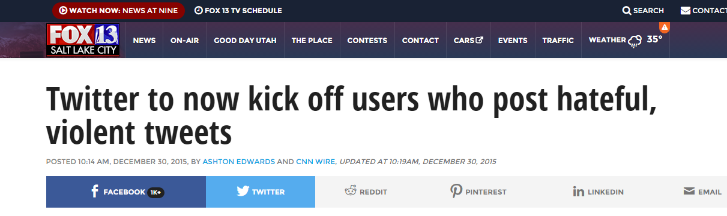

Figure 1: Twitter as an organization is working toward solving this problem as well

On the same line, Apple has released an app named “HealthKit” for tracking mental health of individuals in last quarter (Quarter 4 - 2015) and has shared plans on roadmap of this app as well.

**1.4 Challenges in Social Media**

Tracking mental health behavior in an online age could be attempted by tracking social media posts. Online social data has in general has two famous outlets, blog posts and Twitter/Facebook. Blog posts are   very difficult to sample content from a large number of unique users. One possible way to use blog posts is to connect with 4k sampled unique user’s blog individually and download their content. This is a non scalable approach since it involves detection of user of interest, finding their blog posts and then downloading content one by one. Twitter on the other hand makes it very easy with its open interface architecture. We can plugin the API to get access to samples from a public stream.

Despite twitter’s ease of access to data, it has few unique challenges. Firstly, Twitter provides a very conducive platform for the rapid development of online rhetoric. These rhetorics neither appear in dictionary nor are formally recognized as a part of language. But it carries semantic meaning to large number of users and it is therefore critical to identify user’s intent from the rhetorics. Secondly, 140 characters’ limitation on tweets forces users to place many words together with incomplete and incorrect spellings. This makes data processing and building models in NLP domain a challenge. This is partially unsupervised problem in some sense, as we do not have a priori knowledge of all possible terms that are indicative of mental well-being. Furthermore, these terms are changing constantly, as new terms appear on the fly in response to changing circumstances.

**1.5 Major Contribution**

We wanted to study users who were filtered under broader criterion like “negativity over

all” or “sharing toxic content”. Further we wanted to study in detail if sharing of negative

and toxic content on social media could be a potential proxy for underlying mental illness.

We focus on such filtered users based on not only toxic or negative content they share, whom they follow, who follows them and what signals they choose to amplify. Along with our own sentiment analysis algorithm, by adding network features, we seek to improve detection accuracy.

For detection of such user at high scale, we use generative statistical model Latent Dirichlet Allocation (LDA) from Natural Language Processing (NLP) domain, which allows set of observations to be explained by unobserved groups. Our goal is to design a scalable pipeline which could, use twitter data in holistic way, using scalable machine learning technique. Our pipeline should also tune its learning by training on incoming data incrementally over a period of time. Incremental learning would ensure better results with time on unseen test data.

We wanted to avoid using crowdsourcing as validation mechanism. Mental illness in early stages is really subtle and has little or no physical symptoms. Hence, even experienced psychiatrists find it difficult to diagnose it accurately. Hence we could not have left it to internet to decide how good the model was. Another issue with crowdsourcing is, it’s not a scalable approach. We consciously wanted to pick only scalable components for this pipeline, because we wanted the pipeline to work at scale of Twitter [13].

**1.6 Broader Impact**

One such pipeline could not only filter negative users at a very early stage but also unearth hidden pattern associated with negative content on social media.

One such pipeline idea is noble which uses NLP’s generative statistical model technique to filter and create unsupervised cluster of users, is capable of classify unseen users based on content of tweets, could self learn with time to improve accuracy and fall backs on an improved sentiment analysis algorithm for validation.

The rest of the thesis is organized as follows: CHAPTER 2 describes the characteristics of twitter, use of sentiment analysis and topic modelling, clustering techniques attempted and use of smart and efficient visualization technique t-Distributed Stochastic Neighbor Embedding (t-SNE). CHAPTER 3 discusses architecture of pipeline, data preprocessing, and approaches toward exploring useful features using Twitter’s traditional data or topic modelling. CHAPTER 4, takes us through the result and evaluation techniques attempted, while CHAPTER 5 is about testing the pipeline on an unobserved data, to avoid data bias. CHAPTER 6 gives the conclusion of the analysis we have performed and provides some point wise example of what else could be done to further improve the performance.

CHAPTER 2

BACKGROUND

**2.1 Twitter and its characteristics**

Tracking mental health behavior in an online age could be attempted by tracking social media posts. Online social data has in general has two famous outlets, blog posts and Twitter/Facebook. Blog posts are   very difficult to sample content from a large number of unique users. One possible way to use blog posts is to connect with 4k sampled unique user’s blog individually and download their content. This is a non scalable approach since it involves detection of user of interest, finding their blog posts and then downloading content one by one. Twitter on the other hand makes it very easy with its open interface architecture. We can plugin the API to get access to samples from a public stream.

Last 4-5 years we have seen a huge surge in effort to design good distributed systems [11], [14] which can handle data at large scale. These systems are also designed to consume huge volume of data to train machine learning algorithm which are specifically

designed to work in distributed setup. This has created opportunity for researchers and scientist to create bio-surveillance systems which are predictive in nature and consume social media as input. Some noticeable works are predicting PTSD [10], Postpartum changes [15] using social media as input to name a few. While there has been lot of quality work using twitter as a medium to detect and predict specific mental health disorders, we will use this section to mention few of the most correlated with our problem

definition.

As a part of literature survey, we investigated different research papers related to mental disorders and use of social media like Twitter and Facebook as user put an increasing amount of personal information on these platforms. Research at Johns Hopkins to use Twitter to track the flu [1] and tweets analysis to provide insight in to metal illness [2] have established methods that can link the content of tweets to disease outbreak as well as specific mental disorders. Another notable work is around discovering co-occurrence Patterns of Asthma and Influenza [3]. There has been lot of work on finding accurate sentence sentiment of given short text using multiple techniques. However, work by Sara Rosenthaon combined study of many popular algorithms to find most accurate sentiment [4] was most comprehensive. The impact of celebrities’ influence on their followers was also studied in detail [5]. Looking at related area research papers, we have concluded to the best of our knowledge, that no direct work has been done to detect toxic content sharing among people. Further, most of the early attempts are very specific to one mental conditions. [8][9] [10]

**2.2 Sentiment Analysis**

Sentiment analysis has been handled as NLP task at many levels. Starting from document level classification task to (Turney, 2002; Pang and Lee, 2004), to at the sentence level (Hu and Liu, 2004; Kim and Hovy, 2004) and most recently at the phrase level Wilson et al., 2005; Agarwal et al., 2009).

However, for a more detailed and summarized study of role of social media in mental health research, we would like to refer users to De Choudhury 2013. De Choudhury has identified many ways in which NLP can be used to identify and predict mental health issues both at individual and population level.

For population-level analysis, surveys such as the Behavioral Risk Factor Surveillance System (BRFSS) are conducted via telephone (Centers for Disease Control and Prevention (CDC), 2010). Some of these surveys cover relatively few participants (often in the thousands), have significant cost, and have long delays between data collection and dissemination of the findings.

We were interested in usage of negative and positive words used by users. At the same time, we also wanted to know the distribution of positive and negative score for each individual. This was to get an overall sense of mental health by combining it with user’s network feature like who follows user, user follows whom, what is the impact of celebrity count.

We zeroed down on two approaches to handle sentiment analysis. (1) To use TextBlob package. [26] (2) We wrote a python piece of code which works on bag of word model to assign sentiment to a word based on a published sentiment scores file [27]. We will get in to detail of our implementation later in chapter [x] section [y]. We wanted two different approaches one taking sentence context in to consideration and another just using bag of word model.

TextBlob’s [26] python package’s sentiment property returns a namedtuple of the form Sentiment (polarity, subjectivity). The polarity score is a float within the range [-1.0, 1.0]. The subjectivity is a float within the range [0.0, 1.0] where 0.0 is very objective and 1.0 is very subjective. It could take a sentence and return the sentence score.

e.g.

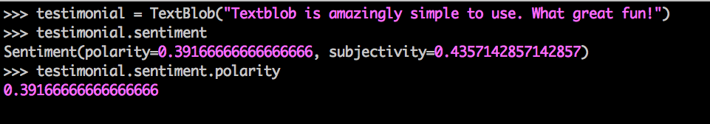

Figure 2: Sentiment score computed by TextBlob package

Reason behind using TextBlob’s sentiment package was it had really consistent and rich set of Application Programming Interfaces (APIs). Additionally, this decision was also influenced by TextBlob’s API’s capability to correct word spelling and spellcheck.

e.g.

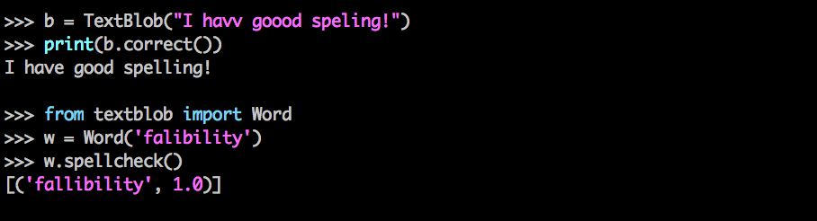

Figure 3: Sentence correctness and Spell check example

Accuracy of TextBlob to convert misspelled words in to correct one was really impressive, but speed was very slow. We believe that it also had something to do with data quality we had. For instance, if we had to look in to a formatted text doc and correct the spelling, the no of occurrences API will have to invoke corrector method will be very less. However, in case of tweets, because its very common to not pronounce word correctly, it was just proving to be overhead. Hence we moved on with our own Dictionary based scorer, which will be discussing in detail in section 3.3.

**2.3 Latent Dirichlet Allocation (LDA)**

In this section we will briefly topic modelling approach LDA[28] we used. In later section 3.5 we will introduce the adaptation of this model for twitter data.

LDA is an unsupervised machine learning technique whose primary purpose is to identify latent topics and word probability distribution for those topics from a large document collection. In LDA each document is represented as probability distribution of topics while each topic itself is probability distribution of words. LDA as a model allows us to play around with number of topic we expect the document to produce and also word in each topic given a word corpus as input. This also clearly indicates that LDA is designed on bag of word concept. In context of this problem, each document here is created by preprocessing user’s last accessible tweets. This kind of unsupervised topic modelling was especially suitable for us as we were looking at generic negative content and later how well each user’s tweet (document) was correlated with topics LDA has figured out.

**2.4 Unsupervised Clustering Techniques**

Two unsupervised clustering used in this experiments to cluster users are:

1. K-Mean [30]
2. Expectation Maximization (EM) [31]

The basic rationale behind selection these two algorithms was to find if the users have clear boundary when they are clustered together (K–Mean would work well) or they have fuzzier distribution. (EM should work well). We used “sklearn. cluster” [32] module of python to perform these clustering operation.

K means

1. Hard assign a data point to one particular cluster on convergence.
2. It makes use of the L2 norm when optimizing (Min {Theta} L2 norm point and its

centroid coordinates).

In contrast, EM

1. Soft assigns a point to clusters (so it gives a probability of any point belonging to any centroid).
2. It doesn't depend on the L2 norm, but is based on the Expectation, i.e., the

probability of the point belonging to a particular cluster. This makes K-means

biased towards spherical clusters.

**2.5 t-SNE (t-Distributed Stochastic Neighbor Embedding)**

t-SNE is a machine learning algorithm for dimensionality reduction developed by Laurens van der Maaten and Geoffrey Hinton. It is a nonlinear dimensionality reduction technique that is particularly well suited for embedding high-dimensional data into a space of two or three dimensions, which can then be visualized in a scatter plot. Specifically, it models each high-dimensional object by a two- or three-dimensional point in such a way that similar objects are modeled by nearby points and dissimilar objects are modeled by distant points [33].

It was well suited for visualization of our user’s cluster as they were expected to have high dimensional data as each topic is one of the dimension of user’s feature vector. We will get in to finer details of our user feature vector in section [x].

CHAPTER 3

PIPELINE ARCHITECTURE

Here is an Architectural overview at a very high level.

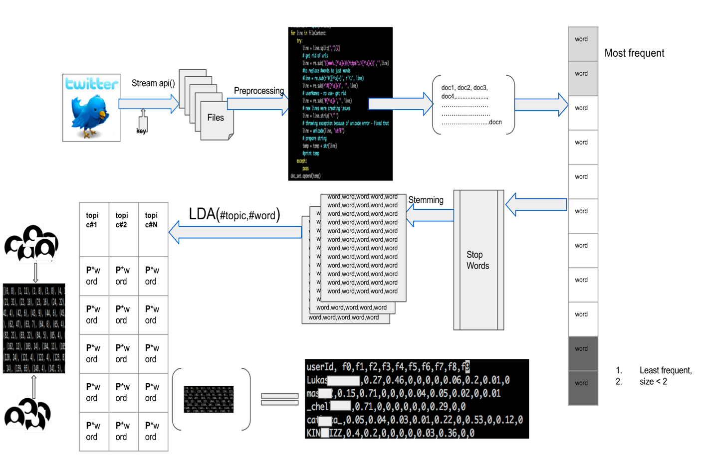

Figure 3: High Level System Architecture for generating user feature vector

This pipeline illustrates how do we calculate user vector based on correlation with topic generated by LDA model.

High level of how Sentiment Analysis and other network feature works.

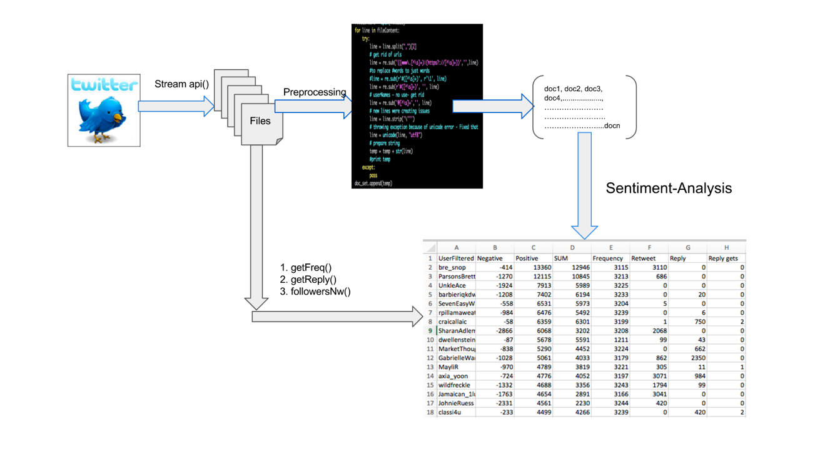

Figure4: High level system architecture for generating a feature vector in terms of user twitter data properties

**3.1 Data Collection**

All the data we obtain is public, and posted between 2014 and 2015 and was made available from Twitter via their APIs. At any point in time we did **not** made any attempt to obtain data which was either marked private or shared via direct message.

We used cloud virtual machine, Droplets by Digital Ocean [34] to download most of the twitter data. Some time when we needed more machine in parallel to work, we used Amazon’s EC2 [35] as well. Twitter provides two ways to access data. Because we wanted the data not to be biased, we went with stream option where we get access to 1% of public stream data without any filter.

Data downloading was mostly divided in 4 phases. Step 1 was achieved using stream API access where as 2,3 and 4 was achieved using REST APIs.

1. Connect to Twitter stream to download tweets from 1% sample access provided by twitter for free. We did this between Nov-Dec 2015. We then filtered user based on their language preference set as English (en).
2. At this stage we had more than 400,000 users. We just selected 10,000 of them randomly and downloaded their last available tweets. Twitter allows developers to have access to last 3200 tweets for a given userid (userid is identity of user on twitter and it has nothing of do with user’s name or any demographic info, it’s just a name which user have chooses to represent her/him on twitter network), using their APIs. We had then data for almost 9000 users as for some of the filtered users had private data policy set.
3. Out of 9000 users, we ran a script to remove users who had less than 100 tweets. The number 100 was selected based on purely experimental basis. We were left with close to 8000 users after applying this filter.
4. For these 8000 users, we also wanted to look at their friend network. Hence we used 6 EC2 machines to download their friends. This was very time consuming as users tend to have many friends. We later restricted the number to 5000 maximum friends for a given userid.

**3.2 Pre-processing**

Extracted tweets were in Java Script Object Notation (JSON) format. We extracted information we needed from this JSON object.

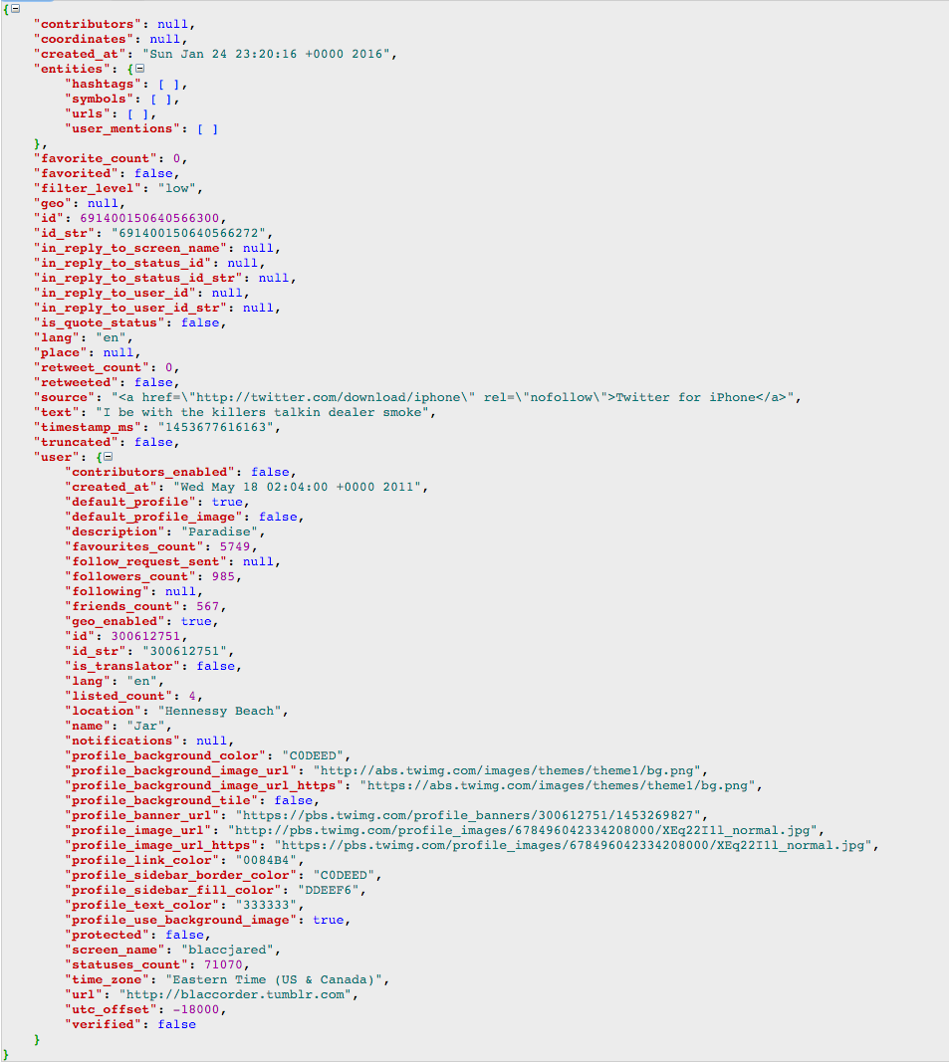

Figure 5 Typical JSON format downloaded from twitter

As we can see that a typical tweet has lot of metadata associated with it. However, we were mostly interested in few very basic ones. At first just to get the user who had set English (en) as their language.

1. **def** extractTweet(inputdata):
2. #count = 0
3. **for** line **in** inputdata:
4. resultDict = json.loads(line)
5. **try**:
6. lan = resultDict["user”]["lang"]
7. **if** lan == "en":
8. var = resultDict["user”]["screen_name"]
9. var = make_unicode(var)
10. **print** (var)
11. **except** KeyError:
12. **pass**
13. **except** ValueError:
14. **pass**
15. **except**:
16. **pass**
18. **def** make_unicode(input):
19. **if** type(input) != unicode:
20. input =  input.decode('utf-8')
21. **return** input
22. **else**:
23. **return** input

Once we had list of these users, we started downloading their last available tweets. For that we used tweepy [36]. We just downloaded in format {id, created_at, text} format

e.g.



Figure 6: Sample of downloaded tweet

once we had a file for each user with this data, we were all set to perform sentiment analysis. These were the basic preprocessing steps we ran on these texts.

1. Remove the part of tweet’s text which had universal resource locators (urls) i.e. https or https
2. Remove hashtags (#), userids (@string), RT, RT”
3. Remove unicode characters
4. Remove the stopwords
5. Convert to lowercase

**3.3 Finding User’s Features using Twitter’s traditional data properties**

After preprocessing, we used TextBlob API to get sentiment score. TextBlob APIs call

produces one sentiment score for a given text. Modifying the source code for it to work on each word as text was overhead and was making program very slow.  Additionally, TextBlob uses inbuilt dictionary for scoring, hence it was not giving any weightage to slangs, shortcuts, and misspelled words which are very common in context of Twitter.

We tried to fix this problem by trying to correct the misspelled words so we could use sentiment scores provided by TextBlob. However, experiment on sample data showed that, TextBlob.correct module was extremely slow. It took on an average two and half minute to process one document (one document is one user’s entire tweet text corpus). Keeping that number in mind we would have needed 2.30 minute each for 4000 users, which is approximately 10000 minutes, which is approximately 150 hours. Even with 3 machine working in parallel it was taking 2 days for one run. And we wanted to run it for all the possible topic counts like, 10, 20, 30, 40, and 50.  Hence we went ahead with our own sentiment analysis code.

We used a simple algorithm which iterates over each tweet of a given user, after doing the preprocessing step, it tokenizes the words and then looks into to dictionary item for the score associated with the found word. It then based on sign of number (positive integer for positive word, negative integers for negative words) add the numbers to positive score or negative score.  This is a bag of word based model to compute the positive and negative score for each user. For creating a rich set of word and sentiment score we merged sentiment scores from two different sources to create a single word to score file. The negative word and files were:

1. AFINN-111.txt [27]
2. Negative-word.txt [36]

When a word was not found in dictionary, we gave it a zero (neutral) score. We cross validated it with TextBlob’s sentiment module. We were getting 13 out of 20 users same in the top negative list. We plotted these top 20% users to get a sense of trend.

**3.3.1 Users who fell in top 100 category of sharing negative content**

Figure 7Users sorted on negative score

We also plotted users to whose negative contribution to social media was more than positive ones, i.e. the graph of user sorted on total score (positive + negative).

Figure 8: User sorted on total score( negative + positive)

**3.3.2 Positive to Negative sentiment correlation**

We also looked at the distribution of positive to negative score across users to figure out how the distribution.

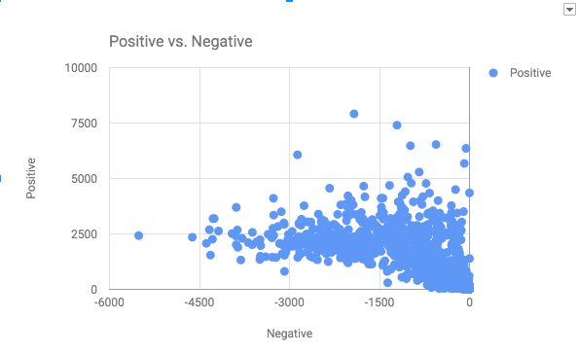

Figure 9: Positive and Negative distribution of scores across 1k sampled users

Distribution was showing a clear trend that some users were polarized to share negative content [between -4500 to -3000] predominantly, but also had positive sentiment score of 1000-2500. However, users with high positive sentiment (greater than 5000) were sharing very less negative content.

**3.3.3 Sentiment correlation with “reply user does” and “gets”**

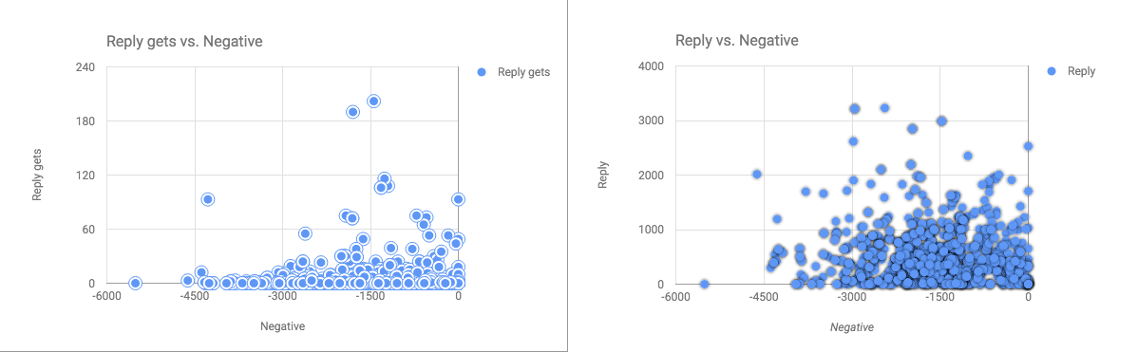

Figure 10: Negative to Reply and Negative to reply gets

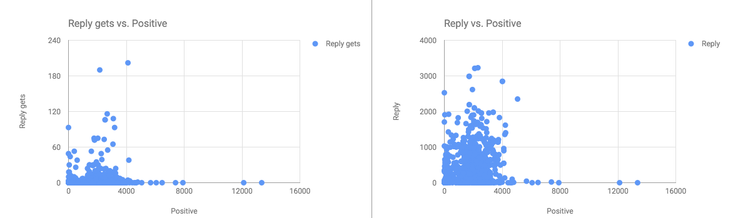

Figure 11: Positive to reply and reply gets

Above graphs suggest that top 1% of negative user tend to reply lot more than top 1% positive users. This is a good signal to utilize as it seems user who have high negative score, get involve in communication with network users.

**3.3.4 Sentiment correlation with “Retweet Count”**

Next we plotted Below average negative to retweet count and above average positive to retweet count as well to see if there was something obviously standing out as trend.

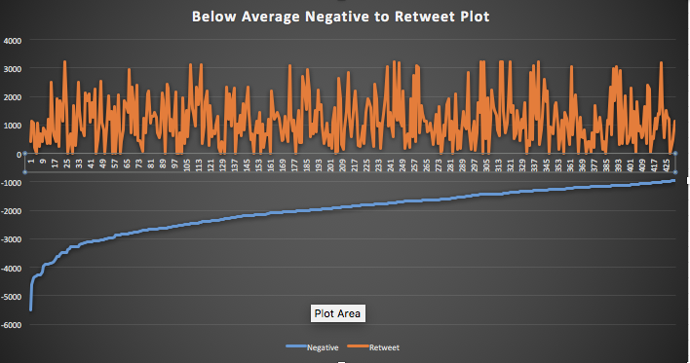

Figure 12 “Below Average Negative Sentiment” to “Retweet Count”

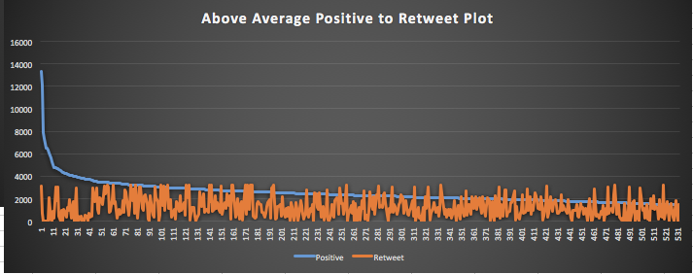

Figure 13 “Above average Positive Sentiment” to “Retweet Count”

The plotted graph suggested that there wasn’t any pattern in the data we had for experiment. So we stopped pursuing this for feature selection.

**3.3.5 Sentiment correlation with “correctness (spelling) of tweets”**

However, there were few interesting patterns about sentiment to sentence correctness factor. We found it quite fascinating that there was obvious link between sentence correctness to negative sentiment.

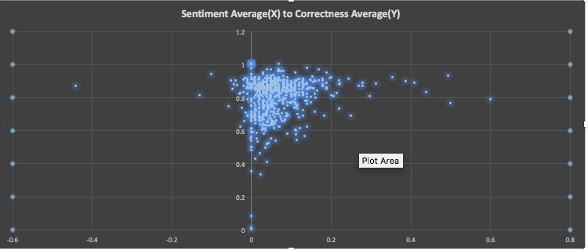

Figure 14Sentiment to Correctness correlation

The graph seems to be suggesting that while low sentiments did not had a clear correlation with correctness, the most positive ones also had a very high correlation score. However, it could not use it as a strong feature.

**3.3.6 Sentiment correlation with “Choice of words”**

We also investigated the idea if “choice of word” was different for people who were mostly tweeting negative in comparison to random people. For this after doing preprocessing steps on tweets, we ran a simple wordcount program to look at the frequency of words.

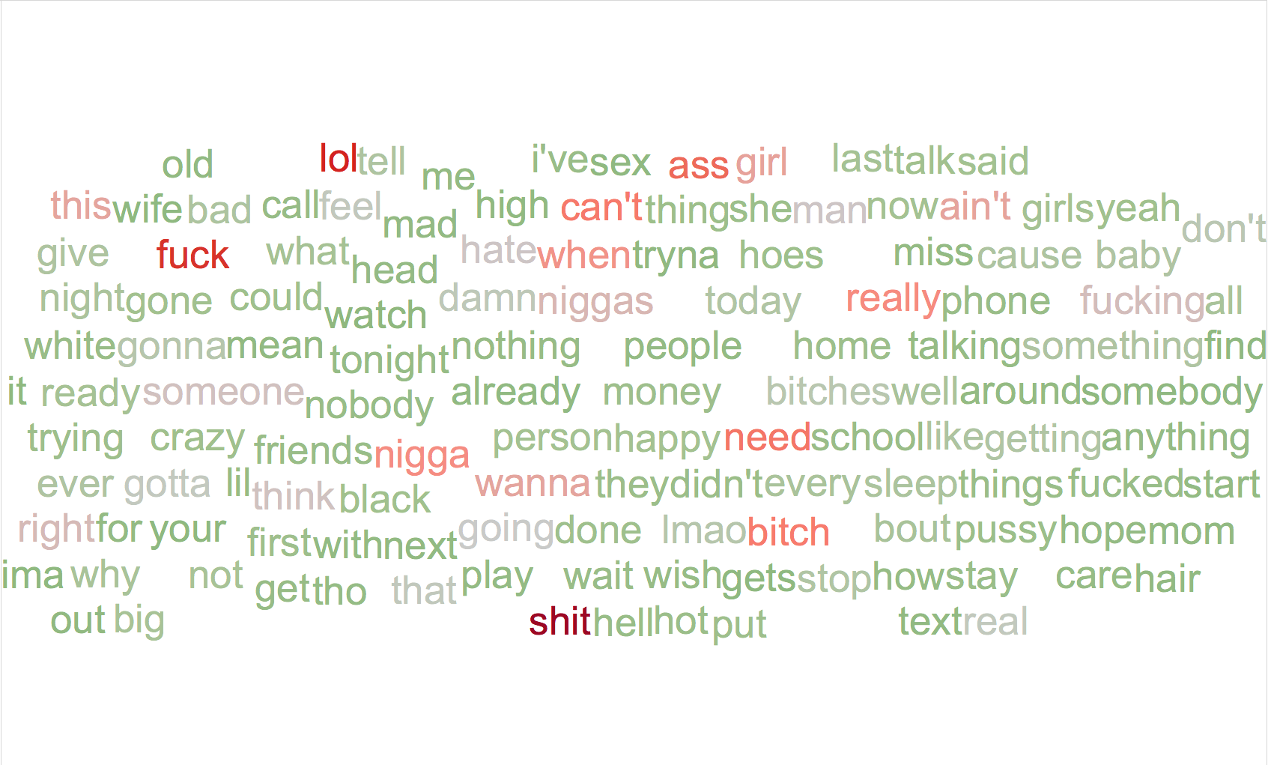

Figure 15 Wordcloud of “choiceofwords” of 20 most negative users

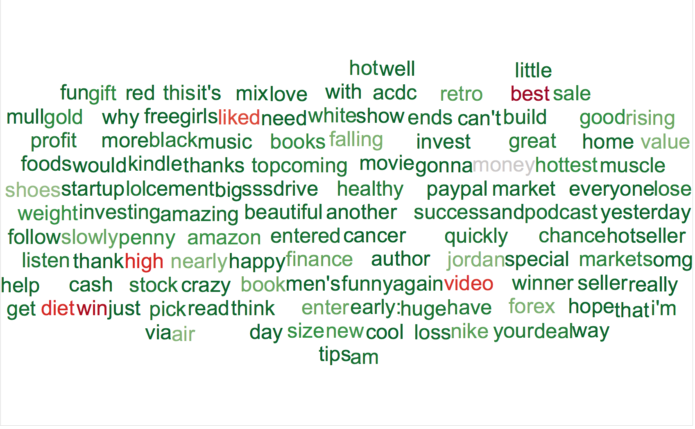

Figure 16Wordcloud of “choiceofwords” of 20 most positive users

**3.3.7 User’s network structure**

We also looked at the user’s network structure to catch some strong differentiating network substructure between negative and positive subcategory. We dominantly used Gephi for that purpose. However, we quickly realized that, most of the users whose negative sentiment was dominant, were mostly either “comedy host shows” or “sports club” ids. We downloaded all the friends for userids and created a adjacency matrix representation for it.

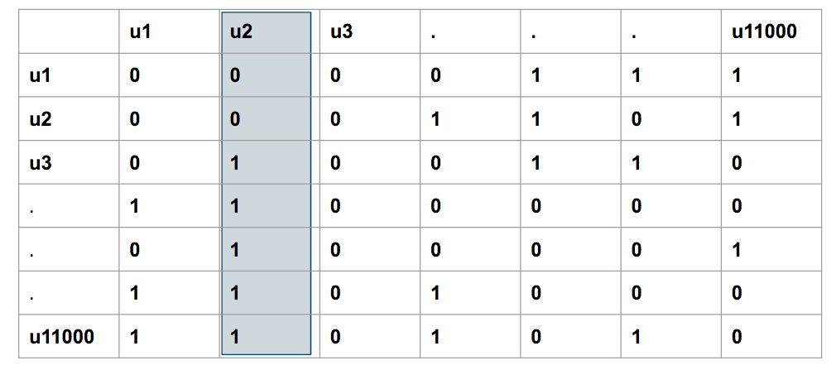

Figure 17: Adjacency matrix representation of user and their friend network

To understand this matrix, a value of 1 at u3,2 represents that u3 has u2 in her/his friend’s list.The idea behind this graph was to find if there were “in-network” celebrities and if their content is affecting the network negativity or positivity over all.

When we plotted this matrix using tool Gephi [37], we got a graph like pasted below. Here, every user is represented by a node and size of the node is proportional to indegree of that node. Also, every edge represents a direct relationship between two nodes.

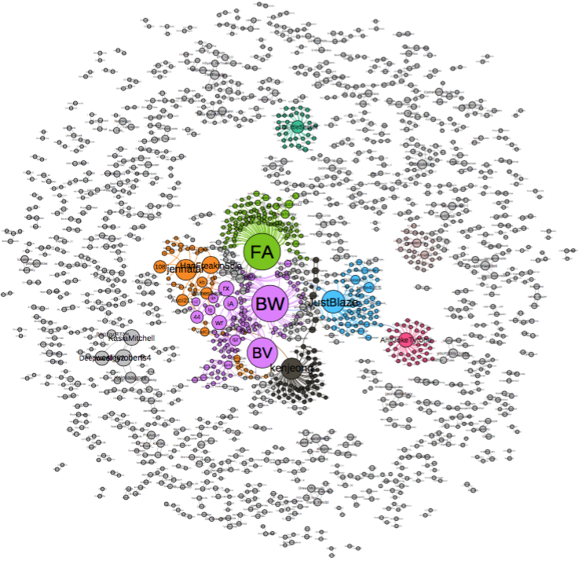

Figure 18 : Network graph of users and their friends inside network

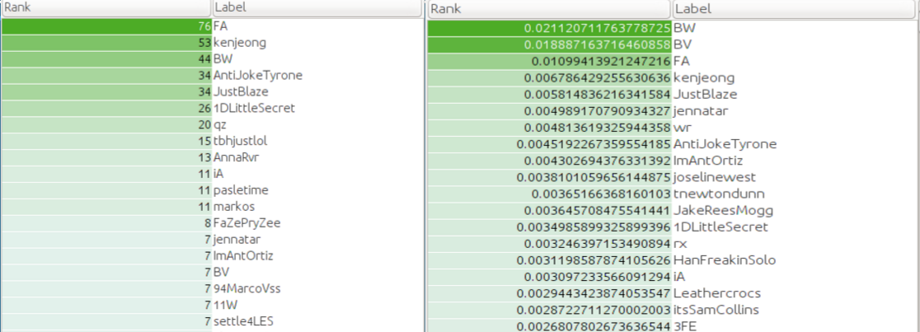

Figure 19: Users in network sorted based on their indegree and pagerank

We did basic manual analysis on users and figured that the users were mostly either comedy shows official page or “one line offensive jokes”. Because most of such ids tweet at a very high frequency, it was very natural for these userids to have high negative sentiment.

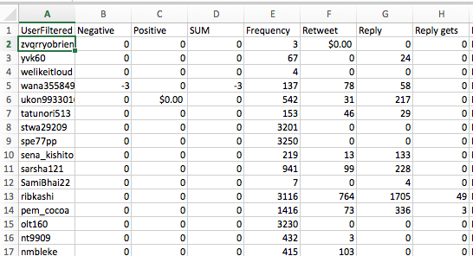

Figure 20Feature vector of each user based on traditional data analysis

**3.4 Finding user’s features using “Topic Modeling” on user’s data**

Hence we decided to try a new pipeline altogether using “Topic modeling” [38] as a technique. Our overall architecture for this, was as described in the following figure.

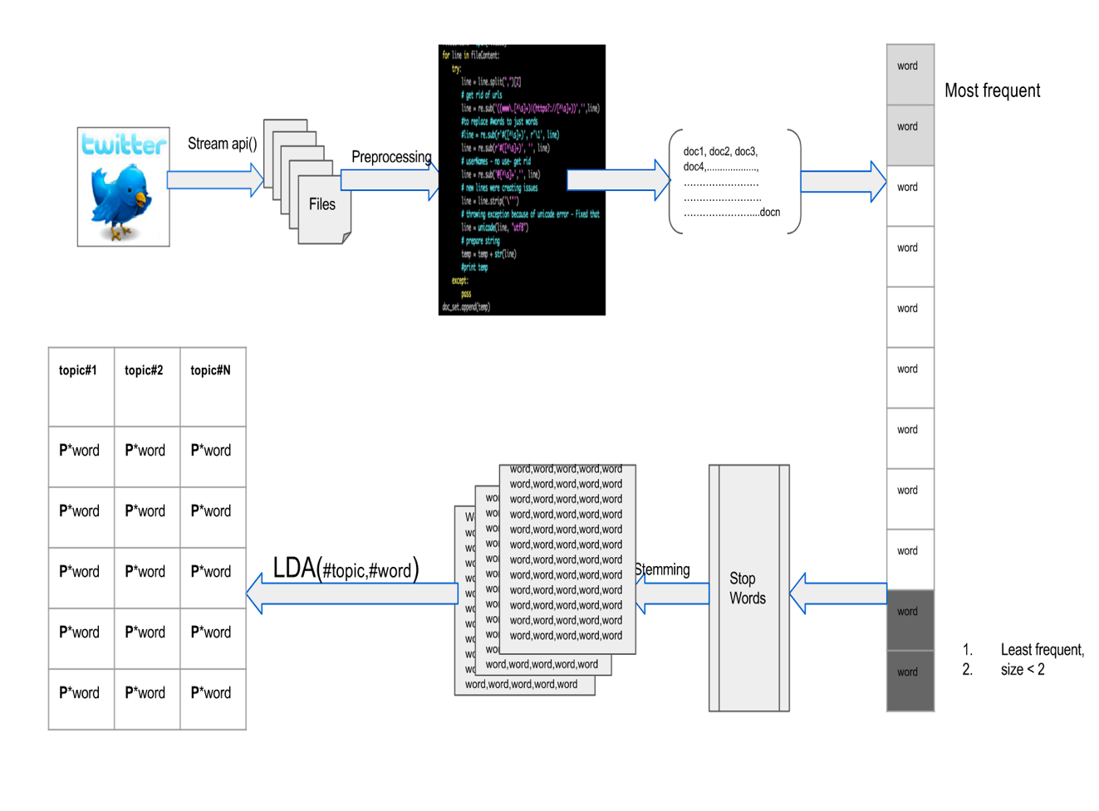

Figure 21: Topic Modelling pipeline design to come up with topics

Steps involved in doing topic modelling over tweet corpus:

1. Data was downloaded as mentioned in section 3.1.
2. On downloaded data, preprocessing steps were applied as discussed in detail in section 3.2. The outcome of this result is to have a clean text corpus for each user, also knows as ‘document’ in this context.
3. Once we had document for each user, tokenize the document set to words.
4. Remove most frequent words as well as least frequent words. This is important to get a good LDA model as the model inherently works on bag of word [40] concept.
5. Remove words which had size < 2 (This step was experiment driven)
6. All stop words had to be removed. We used stopwords from Natural Language Toolkit’s (nltk) stopword's module.
7. We also added few words exclusively as they were meaningless words and must have been generated as a side product of some online rhetoric going on. Here is the list of words we extracted based on experiment output.

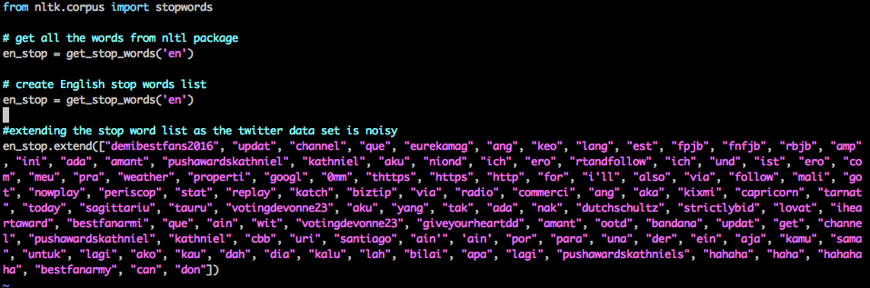

Figure 22: Stopwords used for filtering words

1. Next we perform stemming using PorterStemmer module of NLTK package. Stemming helps extensively in increasing the word quality. As it reduces the multiple variation of words to single one. This helps in keeping the words in dictionary to minimum. E.g. likes, like, liking get converted to same word like after applying stemming.
2. Once cleaning stage is completed, to generate an LDA model, we need to understand how frequently each term occurs within each document. Hence, we need to construct a **document –term matrix.**  We achieve that using package genism. The output of this dictionary creation stage would be a dictionary made of unique tokens. The Dictionary() function assigns a unique integer id to each unique token and in parallel get the wordcount as well.
3. Next the dictionary has to be converted in to bag-of-words. The result corpus, is a list of vectors which will be equal to the no of document (which is the user’s count). doc2bow() function does that.
4. LDA model takes this corpus as input and generates LDA model. It takes input
   1. num_topics: based on this input LDA model generates topic
   2. id2word: needs the dictionary we created in step-9
   3. passes: this is an optional parameter. Typically, this value has to be chosen based on experiments. High value is good, but a very high value can make the algorithm go slow.

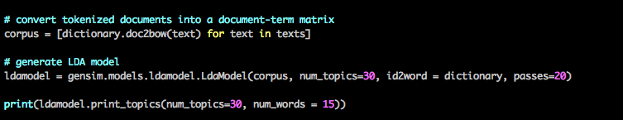

Figure 23: Code Example of How LDA model is Computed

1. Output of above step is list of topics generated by model with probability value aligned with every word generated in each topic. Which is also the last step of Figure-21. We run this for multiple options of num_topics. We experimented with 10, 20, 30, 40, 50 topics.
2. Once a model is generated, it can be saved for it to be used later with a simple command.

**ldamodel.save**('./data/lda_twitter_6310user_30topics.model')

1. The result of above step 11 is (assuming num_topic = 10, num_word = 10)

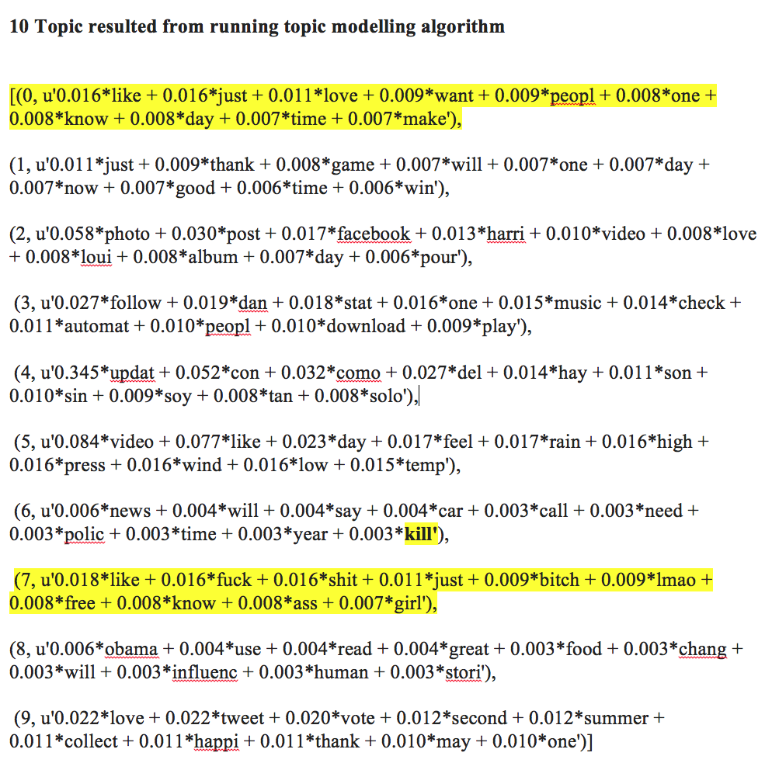

Figure 24: 10 - Topics generated by LDA

1. Once the model generates topic and saved as per step 13, now we can compute the individual document feature vector on the basis of its correlation with topic. For that we compute bag of word for each document and pass it trained LDA model. The output of this step is as follows.

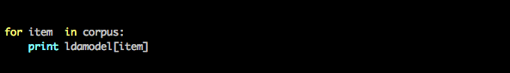

Figure 25 Code Snippet to Print User's Individual Feature vector

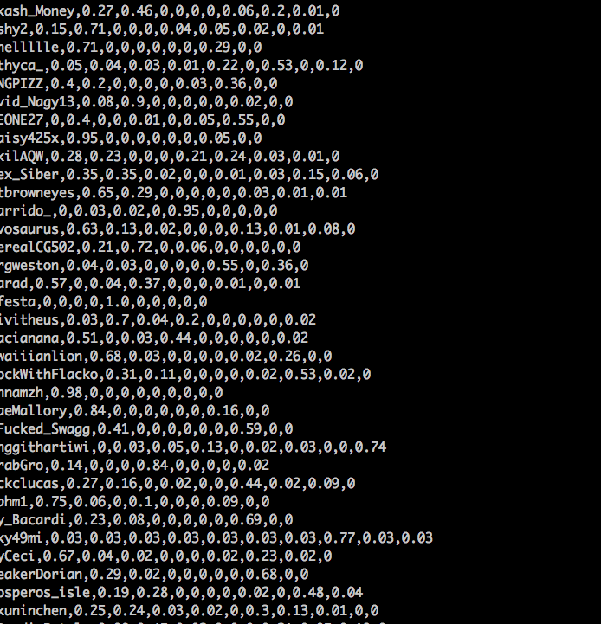

Figure 26User Feature Vector in Correlation with Topics

CHAPTER 4

RESULTS AND ANALYSIS

**3.3.8 Clustering on Twitter’s Traditional Data**

On this feature vector data, we tried to run EM, an unsupervised clustering algorithm.

The expectation was that it should be able to cluster the most negative users in one group.

EM run on this dataset gave us 7 possible clusters.

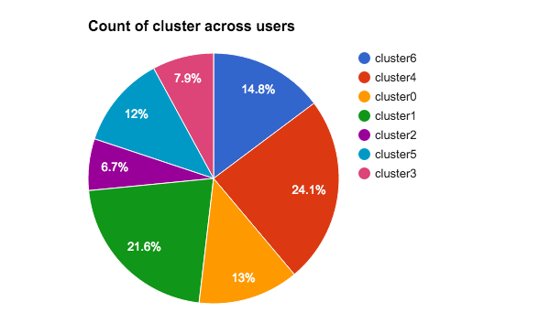

Figure 27Distribution of clusters across dataset

However, most of the top 20 most negative users based on negative sentiment score were clustered in single group.

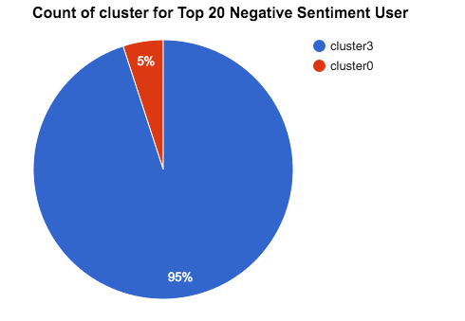

Figure 28: Cluster distribution for top 20 users

This was good result, as EM clustering algorithm was able to find correlation between all negative users. So we ran another experiment by tagging all users who had above average negative sentiment score as negative user and tried to see how the cluster distribution looks like.

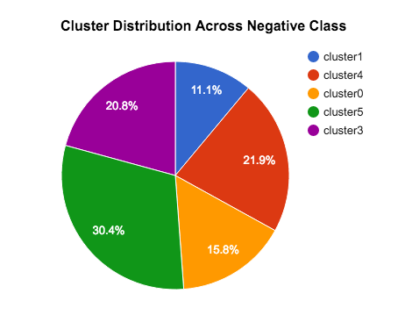

Figure 29Cluster Distribution of all users marked as Negative

This result was not very encouraging as the negative users were all over the cluster. So, while the clustering did a really good job on top negative sentiment user, over all the cluster distribution was not okay keeping twitter traditional data properties as feature. We were also concerned about Sentiment analysis getting too much weightage in the analysis. In previous attempts [8][9] [10] sentiment analysis was already explored as a possibility.

For the validation of results, we had two obvious options in mind. Either manual tagging or crowdsourcing. Both of them highly impractical and non scalable.

**4.1 Data Distribution Sense**

To get a better sense of feature data obtained from section 3.5, we plotted the feature distribution across data set.

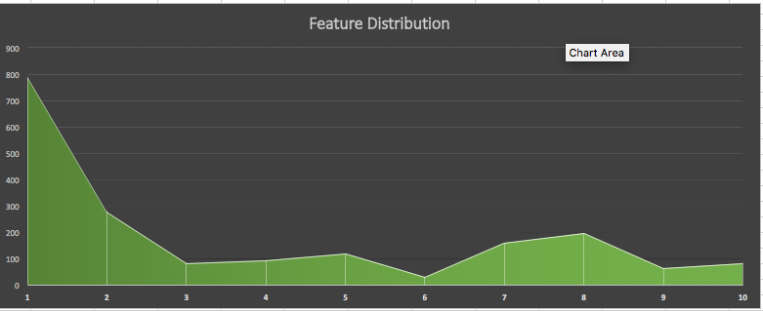

Figure 30Feature distribution – 10 topics

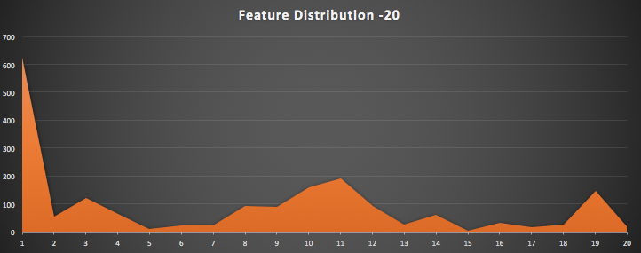

Figure 31Feature distribution – 20 topics

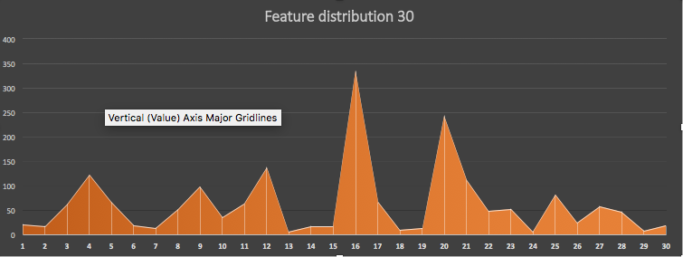

Figure 32 Feature distribution – 30 topics

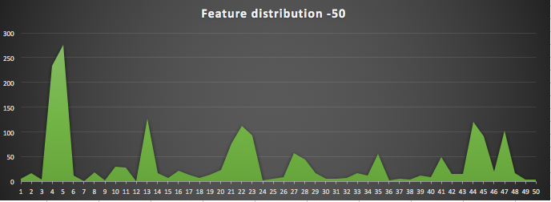

Figure 33Feature Distribution 50Topics

This study was done to get a sense of distribution of each topic.

**4.2 Feature Distribution and Assigning class**

As per Figure-26, we had user’s feature vector available. This could be also seen as user’s feature having 10 dimensional data where each dimension of feature represents one topic in the same order. Hence we plotted the feature vectors of top 20 negative and top 20 positive users to get a sense of feature vector distribution.

Figure 34: Top Negative 20 Feature vector distribution

Figure 35: Positive 20 Feature vector distribution

above graphs are very very interesting in any aspects and following observation can be made

1. Negative users tweets seem to be concentrated in two dimension, dimension 0 and dimension 7
2. However, positive sentiment feature vector spans across all dimensions and is not limited like Top Negative users.

Based on feature vector, we tried to give one of {Negative, Nonnegative} class to each user. This decision of labeling a user was taken based on logic that “any user whose negative feature value in the user feature vector was higher than median, then that was marked as Negative”.

This is how the distribution of each feature vector looked like for 10 topics.

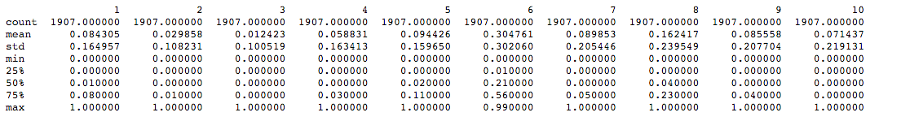

Figure 36Statistics related with 10 features

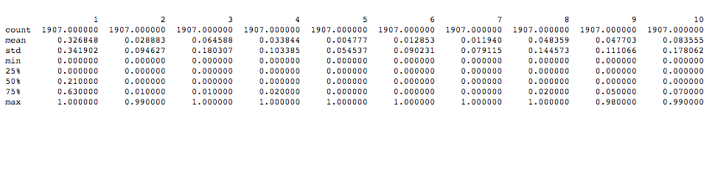

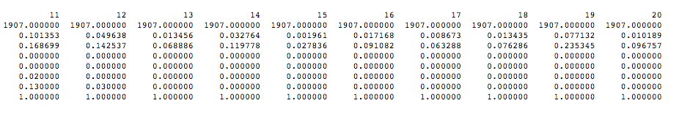

Figure 37: Statistics related with 20 features

Similarly, we computed it for for 30, 40, and 50 features. To find the feature value which represents negative one, we simply look in to the topic distribution as shown in Figure-24 and as from topic it seems obvious that Topic 8 (7 if 0 included) is the negative one. Look at the distribution of feature 8 in Figure-32. Standard deviation is 0.23. Now look at the feature vector of each user in Figure-26. So a simple logic, which takes the feature-8’s value, compare it with the median value. If the the value is greater than the median we marked the user of class “N” (Negative) else “NN” (Non-negative).

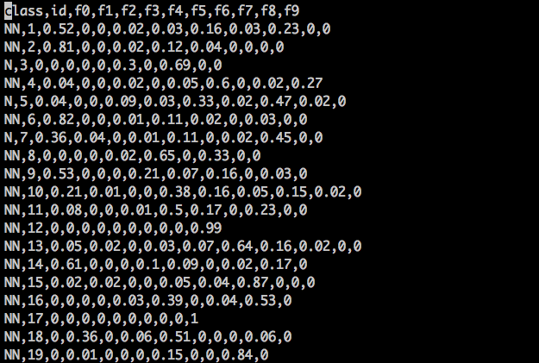

Figure 38: Class included with feature vector

After doing this, to get a sense of class distribution we plotted different feature vectors.

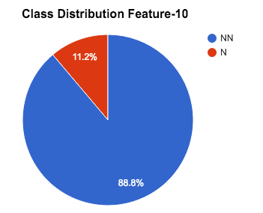 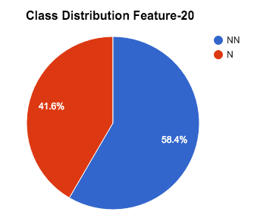 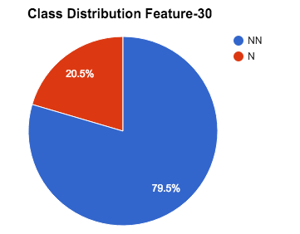 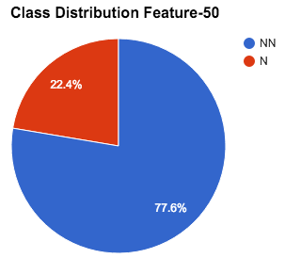

Looking at the class distribution, we can say that this data distribution looks near real time, as data percent of people who use abusive language hovers from 10-20. Hence, next we wanted to see what kind of clusters exists, like we did it for traditional twitter data in section 4.1.

**4.3 Clustering**

We attempted clustering on data represented in Figure 26, to see how many clusters are present.

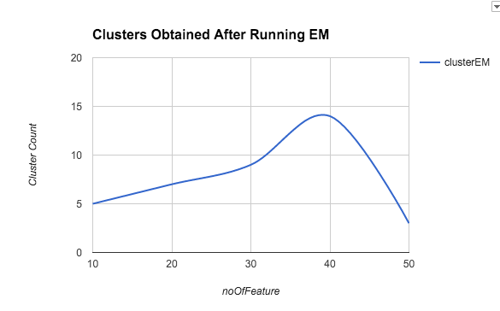

Figure 39: Clusters obtained after running EM on multiple topic size

We studied clustering performed on 10 – topic to understand it in detail.

**4.3.1** **Clustering on 10 Dimensional Feature vector – Explained**

We ran the EM algorithm on Figure-34 data by excluding class feature. EM algorithm represented the entire data set in 5 clusters.

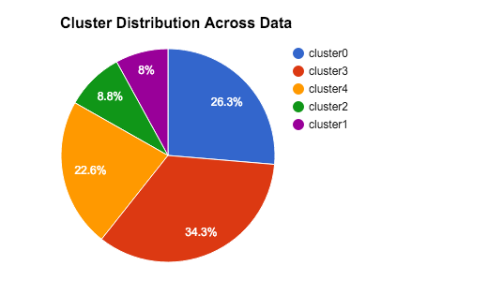

Figure 40: Cluster distribution across data

Next we picked top 20 negative users who were sorted on their negative sentiment score.

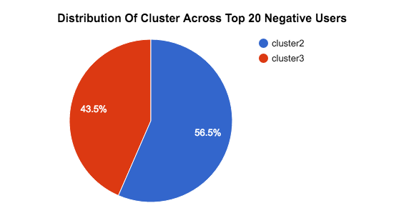

Figure 41: Distribution of cluster among top 20 negative users

Its obvious from graph that the users in top most negative sentiment belonged to either cluster 3 or cluster 2. Next, we wanted to see how the cluster distribution looked like for all negative marked users. Later we also wanted to compare it with twitter cluster distribution, to see if we were doing better with EM on LDA feature or on Twitter’s conventional data set.

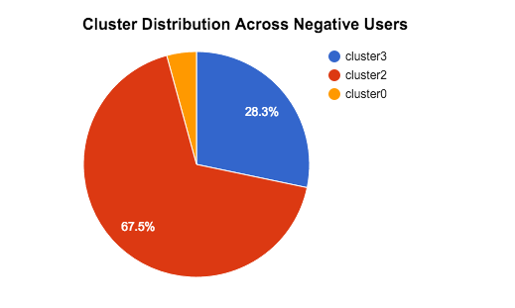

Figure 42: Cluster distribution across all negative users

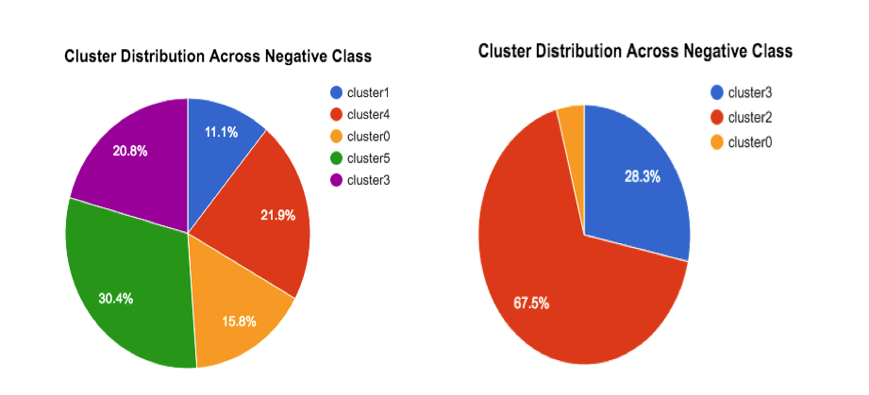

Figure 43: Comparing Twitter negative class clustering against LDA's feature vector's clustering

This is very encouraging, as the negative class is really well concentrated in the LDA feature vector analysis, that means EM could classify the user’s based on their negative feature dominance. As a next step, we were also interested in understanding the logic behind the clustering. Hence, we plotted the feature vector.

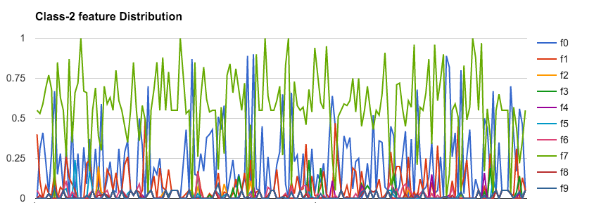

Figure 44: Feature Distribution of users classified with class-2

The graph was suggesting clearly the dominance of f7 (feature-7) as a reason for classifying these users in class-2 category.

We also plotted users who were classified with class-2 with the labels (N/NN) we had created.

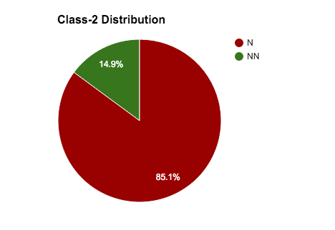

Figure 45: Class -2's distribution on labels N/NN

Which was suggesting very strongly that most of the negative users were marked as class-2. And because the top 20 negative users were marked either class-2 or class-3 we did the similar analysis of class-3

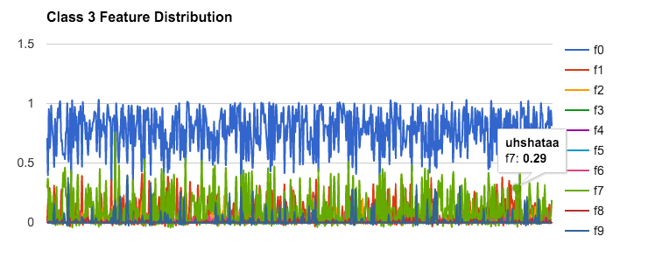

Figure 36Feature Distribution of users classified with class-3

Which was suggesting that while these users had presence of feature 7, feature-0 was dominant. Hence, next we wanted to know, what percentage of total negative users, these class-2 and class-3 hold.

|  |  |
| --- | --- |
| Total N in entire set | 213 |
| Total N with combined classification of class-2 or class-3 | 204 |

Table 1: cluster distribution for user with N class

i.e. 95.7 % of users with N tag were placed in these class with a logic that

* if user had a dominant negative feature: class 3
* if the user had negative feature but not dominant: clsss-2

We did a quick analysis on 30 dimensional feature vector to cross verify if clear trend seen in 10 dimensional data was not merely coincidence and on 50 dimensional, because

We wanted to investigate How well the trend seen with 10 and later 30 holds when the dimensionality of feature vector goes as high as 50.

**4.3.2** **Clustering on 30 Dimensional Feature vector – Explained**

We first had the 30 topics generated from the same word corpus. Later we again picked the same top 20 with most negative sentiment users and plotted their feature vector.This is how the feature vector distribution looked like.

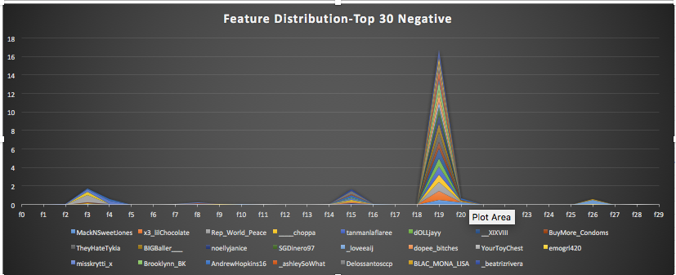

Figure Top 20 Negative Feature vector distribution

From feature distribution its evident that, for top 20 most negative sentiment users have a strong f19, and f3 and f15 of similar strength. Here is what those features are.

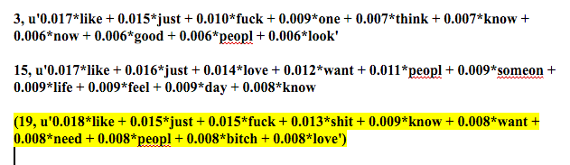

Figure 48: Topics which were showing dominance for most negative users

This is good, as this is inline with what the analysis suggested for 10 dimensional user feature vector. To cross check we also plotted the top 20 user’s feature distribution, and this is how that looked like.

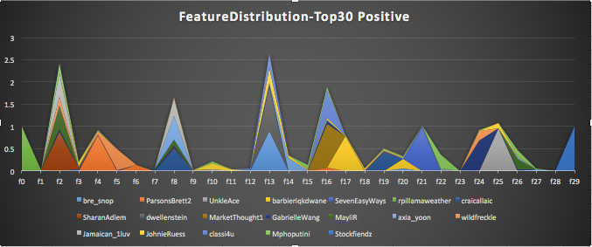

Figure 49: Top 20 Positive Feature vector distribution

Which is also inline with our early observation that, while negative user’s tweets are really focused, positive ones like to talk about almost everything. Next we wanted to see how the over all cluster distribution looked like.

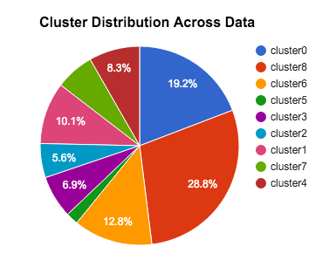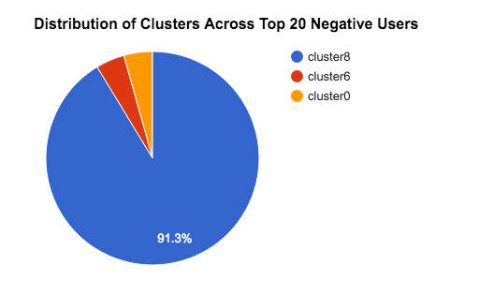

Figure 50: Cluster distribution across data and Top 20 Negative users

Figure-43 suggested that negative users were clusters in group cluster-8. Hence, we also wanted to have another look at the total negative user distribution across clusters.

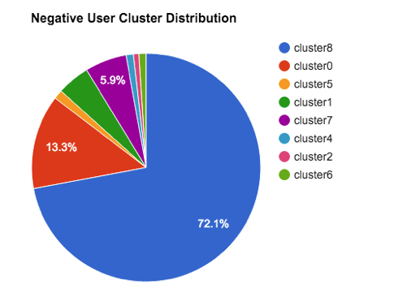

Figure 51: Negative user cluster distribution

Above infographics suggested that, 85 % of the total negative users were concentrated in two the clusters {cluster 8, cluster 0}. Which is always an indication of algorithm being able to group similar users in some space. Further analysis on cluster-8, gave a reasoning on clustering.

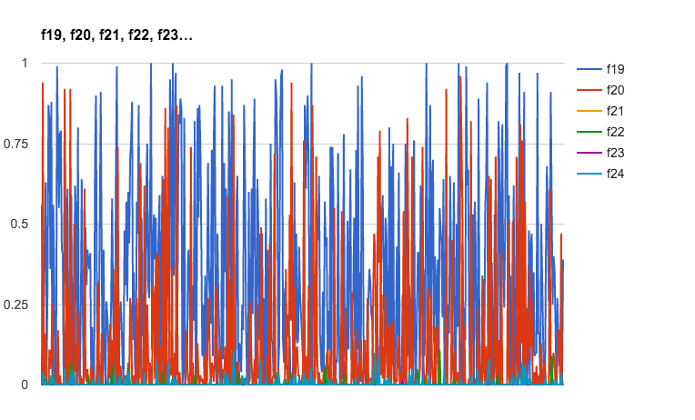

Figure 52Cluser-8 was designed based on f19 being the dominant feature

Upon experimenting further with feature vector sized 20, 40, and 50, we realized that the trends were just getting repeated. Hence we choose not to include that as a part of this document. Next challenge was to view these datasets in form of cluster.

**4.4** **Cluster Visualization using t-SNE approach.**

t- Distributed Stochastic Neighbor Embedding (t-SNE) is a technique designed for dimensionality reduction, that is particularly well suited for the visualization of high dimensional dataset. This was perfect for us. Here is the visualization we got when we plotted them in unsupervised (by ignoring class N/NN) and later by including class definition. This is how trial run looked like on on multiple size dataset.

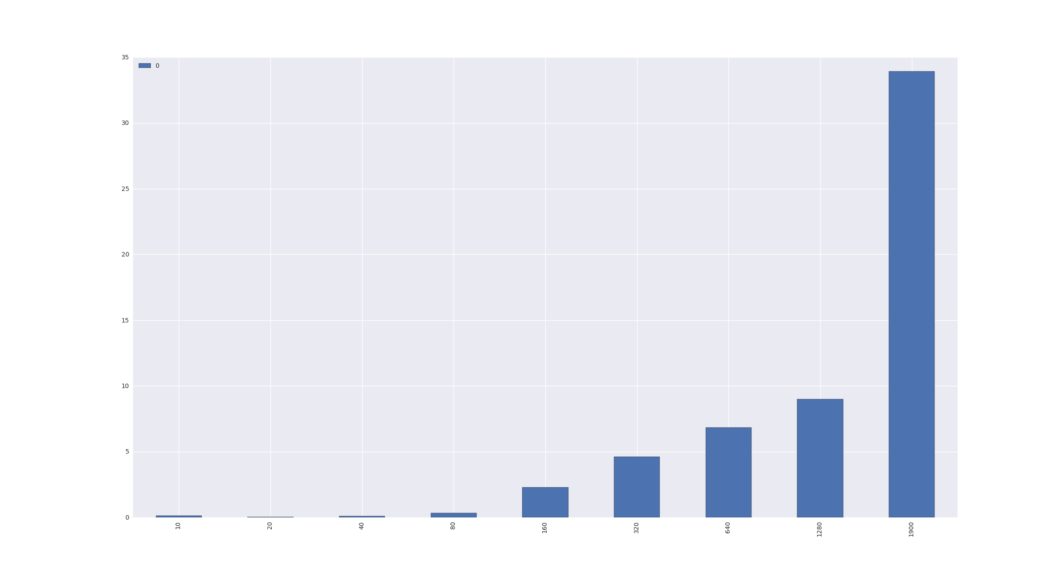

Figure 53 Shows how the run times increases with increased data size – O(n2)

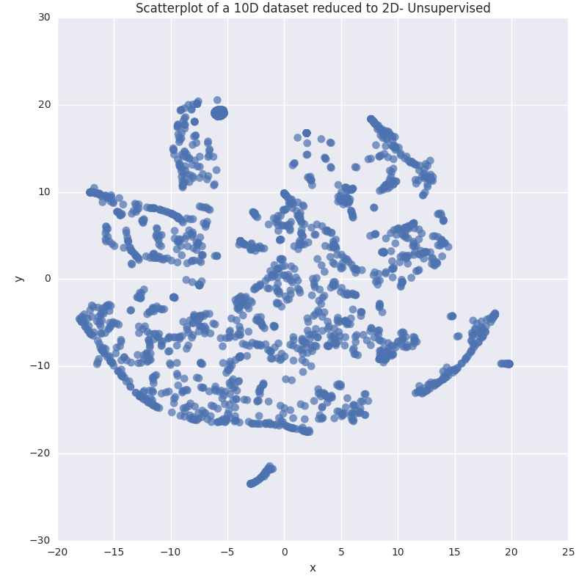

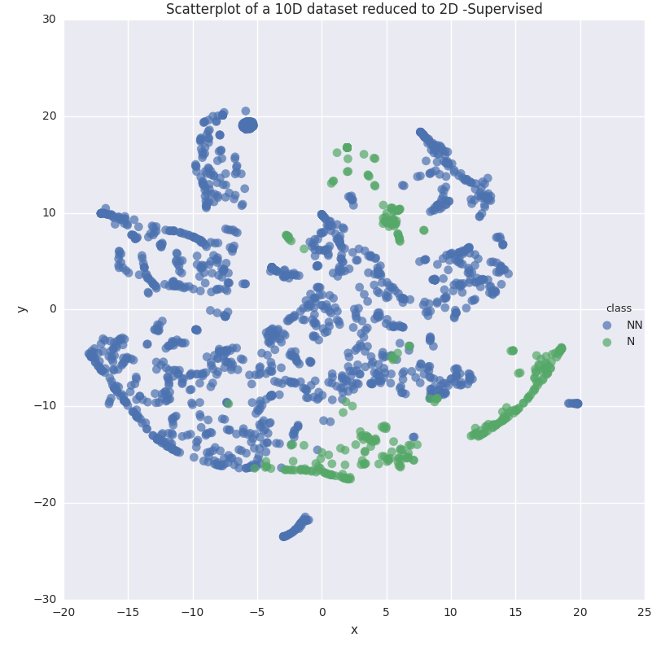

Figure 54: tSNE 10 Dimensional projected on 2 D - Supervised

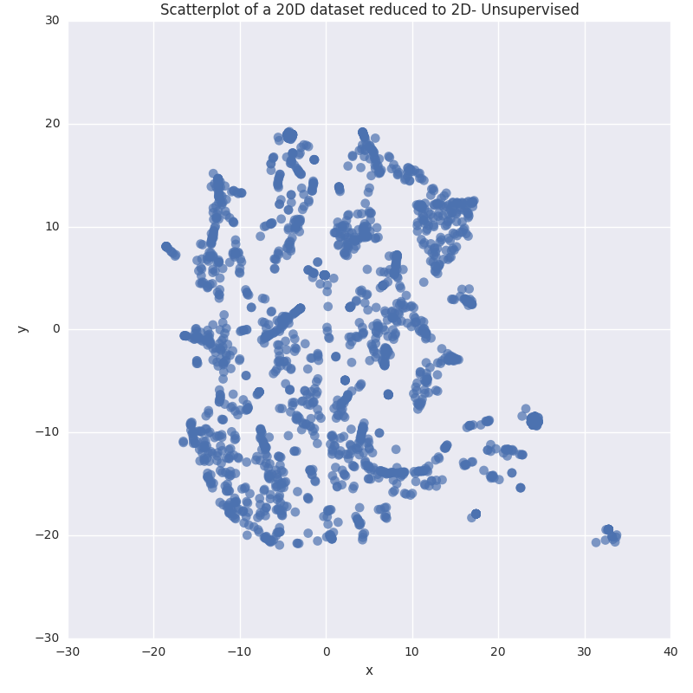

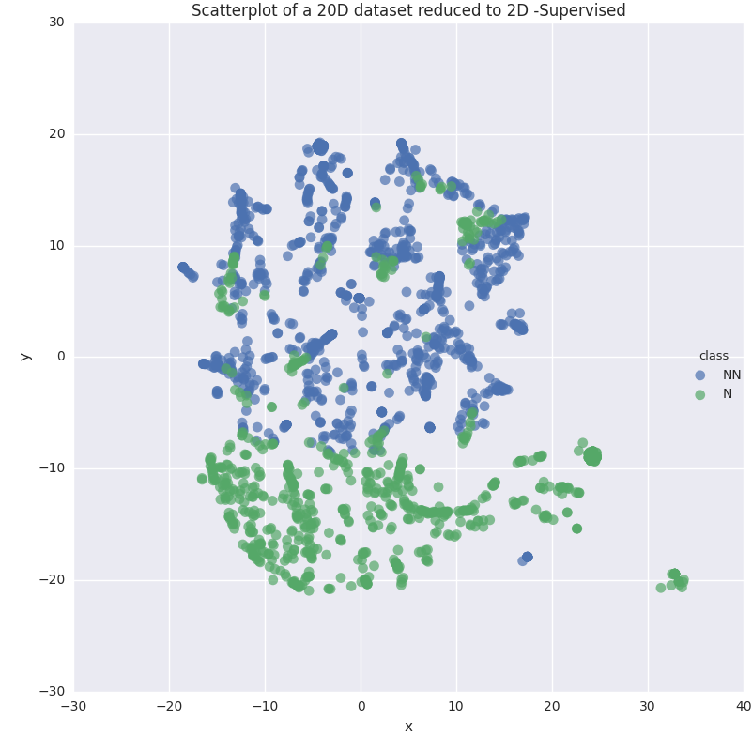

Figure 55: tSNE 20 Dimensional projected on 2 D - Supervised

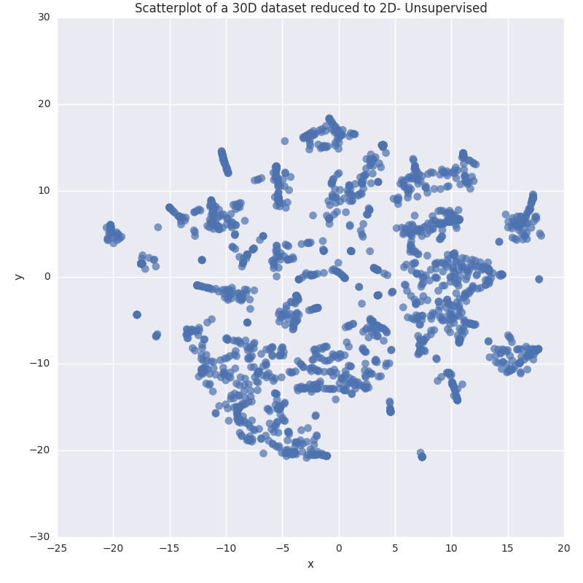

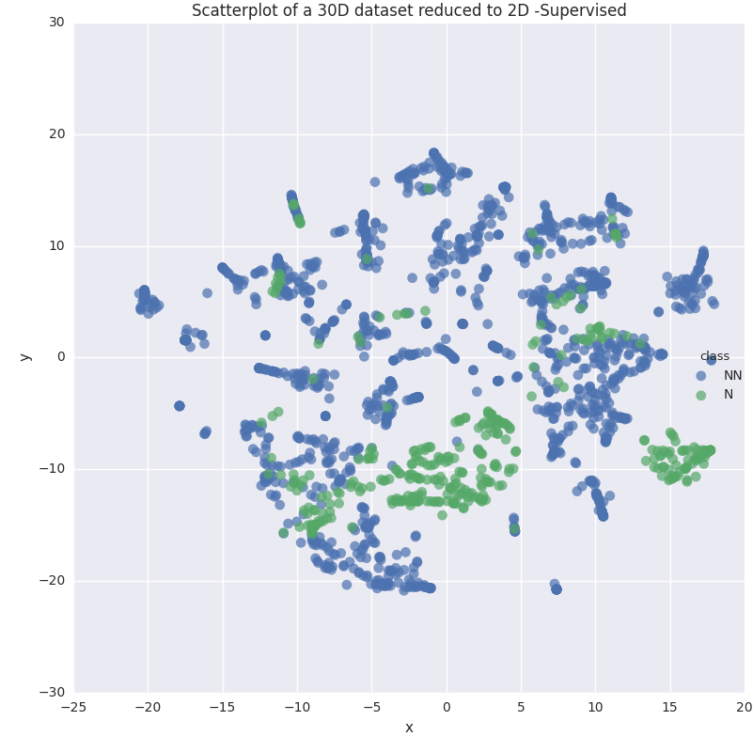

Figure 56: tSNE 30 Dimensional projected on 2 D - Supervised

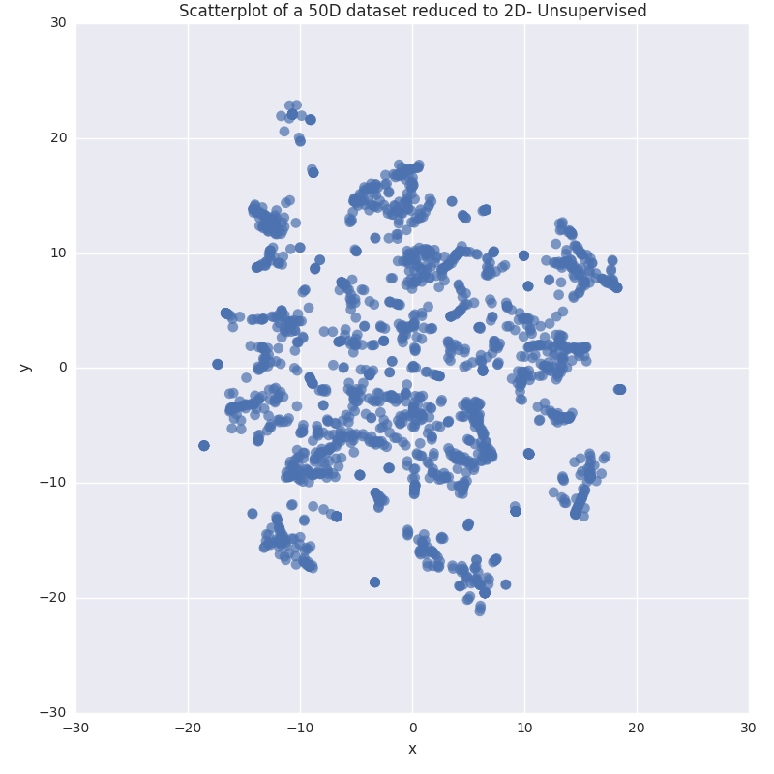

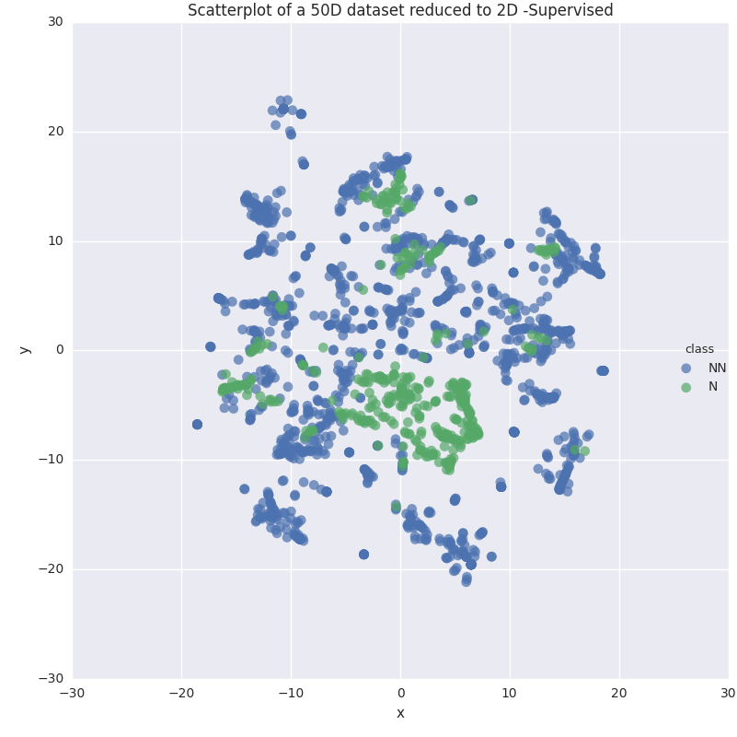

Figure 57 tSNE 50 Dimensional projected on 2 D - Supervised

CHAPTER 5

EVALUATION

Results we got from EM Clustering on feature vectors, irrespective of its size, were very consistent with singling out extremely negative users from moderate one to the positive ones.

The combination of topic modeling and sentiment analysis was working great, as either one of these could be used as validation mechanism for another. However, in context of a scalable pipeline, LDA as primary method will make more sense. The reason being LDA has many distributed implementation available. Sentiment analysis could be used for validating in distributed set up as well using dipsy [40]. Together, they make a pipeline, which is less prone to false positive errors. Hence can successfully filter users with most abusive or negative content.

As an independent validation mechanism, we downloaded set of 6300 user’s tweet independently and ran it through our pipeline. clusters made by feature detected out of LDA, could detect all the negative users, and sentiment analysis on the same set of users gave us 87 out of 100, same users. This study was done to establish that primary data on which analysis was done did not had any bias toward negative users and there was always at least one negative topic present in the topics generated. However, we must mention that we only validated this with topic count 20 and 30.

Please find below the experiment results with similar analysis as done on test data.

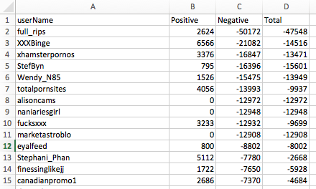

Figure 58: Top 15 most negative user

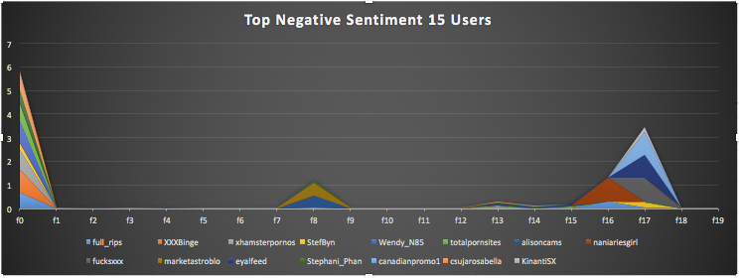

Figure 59: Feature distribution of top 15 users

[(**0**, u'0.028*hot + 0.020*fuck + 0.018*ass + 0.018*sexi + 0.014*porn + 0.014*girl + 0.012*blond + 0.011*amaz + 0.010*bdsm + 0.010*sweet + 0.009*wild + 0.009*kinki + 0.009*insan + 0.009*sizzl + 0.009*babe'),

(**1**, u'0.015*hahahahaha + 0.007*hehe + 0.007*hahahahahaha + 0.006*score + 0.006*anonym + 0.006*man + 0.005*nako + 0.005*gameid + 0.005*miss + 0.005*huhu + 0.005*wala + 0.004*incognito + 0.004*nalang + 0.004*goooaaal + 0.004*akong'),

(**2**, u'0.032*win + 0.017*enter + 0.011*deal + 0.010*chanc + 0.009*collect + 0.009*just + 0.009*black + 0.007*giveaway + 0.007*size + 0.007*set + 0.006*contest + 0.005*end + 0.005*men + 0.005*gift + 0.005*card'),

**(3**, u'0.028*may + 0.018*now + 0.017*follow + 0.015*might + 0.013*automat + 0.011*check + 0.011*person + 0.010*one + 0.008*feel + 0.008*peopl + 0.007*book + 0.007*just + 0.007*chang + 0.006*life + 0.006*cancer'),

**(4**, u'0.028*kabc + 0.017*trump + 0.006*say + 0.006*obama + 0.006*hillari + 0.005*berni + 0.005*donald + 0.005*clinton + 0.005*vote + 0.005*isi + 0.005*will + 0.005*kill + 0.004*sander + 0.004*peopl + 0.004*debat'),

**(5**, u'0.013*yung + 0.009*mga + 0.008*may + 0.008*naman + 0.008*love + 0.007*talaga + 0.006*hindi + 0.006*happi + 0.006*vote + 0.005*tweet + 0.005*yan + 0.005*nga + 0.005*main + 0.005*kaya + 0.005*pag'),

**(6**, u'0.016*guru + 0.014*bless + 0.014*msg + 0.010*fan + 0.009*human + 0.009*papa + 0.008*dhan + 0.007*god + 0.007*movi + 0.007*craze + 0.006*wow + 0.006*love + 0.006*great + 0.005*good + 0.005*work'),

**(7**, u'0.011*goal + 0.010*score + 0.010*game + 0.009*arsen + 0.009*leagu + 0.009*win + 0.008*player + 0.008*messi + 0.008*barcelona + 0.007*season + 0.007*team + 0.007*unit + 0.006*west + 0.006*fan + 0.005*chelsea'),

**(8**, u'0.019*lol + 0.017*like + 0.012*fuck + 0.012*just + 0.012*shit + 0.009*nigga + 0.008*know + 0.007*lmao + 0.006*bitch + 0.006*need + 0.006*ass + 0.006*man + 0.006*girl + 0.005*time + 0.005*good'),

**(9**, u'0.042*inc + 0.018*trade + 0.018*share + 0.014*manag + 0.013*corp + 0.013*sell + 0.013*rate + 0.012*price + 0.011*llc + 0.011*invest + 0.010*buy + 0.009*stake + 0.009*group + 0.008*capit + 0.008*een'),

**(10**, u'0.013*india + 0.007*hai + 0.007*delhi + 0.006*will + 0.006*ani + 0.004*indian + 0.004*pakistan + 0.004*govt + 0.004*nation + 0.004*modi + 0.004*court + 0.003*bjp + 0.003*jnu + 0.003*day + 0.003*case'),

**(11**, u'0.939*updat + 0.016*latest + 0.007*fin + 0.006*dolphin + 0.004*photonot + 0.000*text + 0.000*mod + 0.000*ejuic + 0.000*yoonaya + 0.000*twb + 0.000*line + 0.000*save + 0.000*tank + 0.000*code + 0.000*shop'),

**(12**, u'0.116*music + 0.106*trend + 0.098*search + 0.093*gay + 0.092*vid + 0.092*hottest + 0.090*militari + 0.020*zayn + 0.015*harri + 0.014*loui + 0.011*direct + 0.011*pleas + 0.011*bio + 0.010*ff + 0.010*give'),

**(13**, u'0.007*thank + 0.007*just + 0.007*good + 0.007*day + 0.007*one + 0.007*will + 0.006*look + 0.006*great + 0.006*like + 0.006*time + 0.005*now + 0.005*see + 0.004*think + 0.004*love + 0.004*make'),

**(14**, u'0.010*job + 0.010*market + 0.009*busi + 0.008*video + 0.008*2016 + 0.007*media + 0.007*find + 0.007*digit + 0.006*social + 0.006*make + 0.006*need + 0.006*manag + 0.006*design + 0.005*news + 0.005*tip'),

**(15**, u'0.019*bmh + 0.016*play + 0.014*now + 0.007*game + 0.006*video + 0.005*star + 0.004*2016 + 0.004*found + 0.004*top + 0.003*year + 0.003*season + 0.003*favorit + 0.003*hit + 0.003*basketbal + 0.003*week'),

**(16**, u'0.059*photo + 0.055*video + 0.043*post + 0.029*virgo + 0.027*facebook + 0.019*watch + 0.011*see + 0.007*man + 0.006*buhari + 0.006*nigerian + 0.006*download + 0.006*nigeria + 0.005*thing + 0.005*ladi + 0.005*tauru'),

**(17**, u'0.039*free + 0.031*download + 0.021*app + 0.015*onlin + 0.015*iphon + 0.015*use + 0.014*appl + 0.013*android + 0.012*now + 0.012*wifi + 0.011*googl + 0.009*code + 0.009*stock + 0.008*order + 0.007*avail'),

**(18**, u'0.044*gmt + 0.039*touch + 0.024*usd + 0.023*level + 0.021*figur + 0.015*posit + 0.015*open + 0.015*5so + 0.015*jpi + 0.014*sentiment + 0.014*swfx + 0.011*rank + 0.011*yesterday + 0.011*eur + 0.010*juli'),

**(19**, u'0.082*daili + 0.073*stori + 0.027*organ + 0.024*newspap + 0.020*news + 0.015*make + 0.015*energi + 0.014*food + 0.013*green + 0.013*product + 0.013*follow + 0.013*earth + 0.013*cat + 0.013*renew + 0.013*solut'),

**(20**, u'0.060*eat + 0.039*retweet + 0.037*follow + 0.028*thank + 0.028*stat + 0.014*unfollow + 0.014*back + 0.013*one + 0.013*rihanna + 0.012*vote + 0.012*love + 0.011*pleas + 0.011*now + 0.009*want + 0.009*happi'),

**(21**, u'0.019*manuel + 0.018*toma + 0.012*doc + 0.011*kay + 0.011*papa + 0.010*cardo + 0.010*tom + 0.009*team + 0.008*surf + 0.008*henri + 0.008*naman + 0.008*wave + 0.006*talaga + 0.006*ivan + 0.005*fair'),

**(22**, u'0.116*check + 0.073*buy + 0.068*thx + 0.065*want + 0.065*rule + 0.062*bi0 + 0.062*f0r + 0.062*with0ut + 0.016*hallelujah + 0.010*current + 0.009*humid + 0.009*wind + 0.007*fair + 0.007*amen + 0.006*email'),

**(23**, u'0.006*say + 0.006*will + 0.005*year + 0.005*bank + 0.004*peopl + 0.004*news + 0.004*report + 0.003*polic + 0.003*govern + 0.003*world + 0.003*attack + 0.003*kill + 0.003*state + 0.003*tax + 0.003*break'),

**(24**, u'0.016*like + 0.014*love + 0.014*just + 0.009*peopl + 0.009*want + 0.008*one + 0.007*feel + 0.007*make + 0.007*know + 0.007*day + 0.006*time + 0.006*someon + 0.006*life + 0.006*need + 0.006*think'),

**(25**, u'0.016*wkwk + 0.013*mau + 0.012*itu + 0.012*iya + 0.010*say + 0.010*udah + 0.010*nya + 0.010*gue + 0.009*gak + 0.008*kan + 0.008*juga + 0.007*jam + 0.007*kalo + 0.007*nih + 0.007*pakistan'),

**(26**, u'0.072*instagram + 0.050*eye + 0.049*ladi + 0.049*send + 0.048*featur + 0.048*candi + 0.048*becom + 0.047*section + 0.047*famou + 0.047*sexiest + 0.020*fonethedon1 + 0.018*mixtap + 0.016*congo + 0.016*nigga + 0.016*fiyahhh'), **(27**, u'0.049*eurovis + 0.043*2015 + 0.023*video + 0.013*kimxi + 0.010*lyric + 0.009*tsou + 0.009*photosandbacon + 0.009*thestoryofu + 0.007*lyrik + 0.007*kavinoki + 0.006*kimdireurovis + 0.006*love + 0.006*kim + 0.005*wer + 0.005*notifica'),

**(28**, u'0.015*dan + 0.006*dari + 0.006*dengan + 0.005*bisa + 0.005*orang + 0.004*indonesia + 0.004*tidak + 0.004*akan + 0.004*hari + 0.004*kita + 0.004*foto + 0.003*naik + 0.003*dalam + 0.003*itu + 0.003*jadi'),

**(29**, u'0.009*bila + 0.008*kalau + 0.007*orang + 0.006*kita + 0.006*pun + 0.005*dengan + 0.005*buat + 0.005*boleh + 0.004*tapi + 0.004*kat + 0.004*macam + 0.004*nie + 0.004*hati + 0.004*laa + 0.004*dan')]

This output clearly states the fact that effectively these users are asking people to download porn. Manual validation aligns with observation. Method correctness in detecting user with abusive and negative content was 100 %. The best outcome with this result was it was not only clear that why a user was marked negative but also the context ion which the user was marked negative.

CHAPTER 5

**CONCLUSION AND FUTURE WORK**

**5.1 Conclusion**

To conclude, our proposed framework works in a scalable fashion and with very high accuracy. It can not only detect users who are posing threat because of their abusive and toxic threat but also the context in which they are posing threat.

Our experiments started with 1900 user’s dataset, later we extended the same data set to 4300 users to find the generality in the behavior displayed. Once we were able to successfully not only anticipate public health threats, but also could identify at risk individuals from social media for non contagious disease in the realm of mental health. Based on our results, we have proven that our proposed framework, which combines topic modeling and sentiment analysis to provide an estimate of toxic, abusive behavior can effectively identify and filter a pool of potentially at-risk users via their content on social media. Our framework can also be tuned on incoming data incrementally over a period of time, which ensures better results over time on unobserved data. Such a framework can work at scale, because of careful selection of components. Our final output support our claim that this framework can not only give accurate user detection but also the context in which user was marked negative.

**5.2 Future Work**

While we have done a detailed work on designing the pipeline in most efficient way, here are few areas in which the pipeline performance can be improved further.

1. Sentiment analysis works as bag-of-word model. A more sophisticated algorithm can be used to gather sentiment
2. Network properties of user, can be better utilized and sentiment of a user should be able to consume those properties as well. While we were able to point out how the network of negative users differ from positive one, we could not include them while building our model.
3. While building LDA model, correcting the word could help LDA model, outputting only correct words as twitter is known for misspelled and incomplete words.
4. We could not include online rhetorics generated while doing sentiment analysis. Such rhetorics have lot of contextual meaning. Hence these could be included to get a more accurate sentiment score.
5. Our framework can adjust its learning on incoming text by updating the LDA model with time. However, having a feedback component for the prediction could make learning more accurate as well as conclusive.

REFERENCES

1. <http://www.webmd.com/mental-health/>
2. Sayali Kale UGA Graduate Student Computer Science.
3. ‘Using Twitter to Track the Flu (“Dredze et al 2014”)
4. Analysis of Twitter posts could provide fresh insight into mental illness trends (“Dredze et al 2015”)
5. Discovering Multi-Scale Co-occurrence Patterns of Asthma and Influenza with the Oak Ridge Bio-surveillance Toolkit." (“Ramanathan et al 2015”)
6. ‘SemEval-2015 Sentiment analysis in twitter (“Rosentha et al 2015” )
7. “Retweets but not just Retweets - Quantifying and predicting influence on twitter (Rosemann et al., 2012).
8. Detecting suicidality on Twitter (“O'Dea et al 2015”)
9. Mining Twitter Data to Improve Detection of Schizophrenia (“McManus et al-2015”)
10. Measuring Post Traumatic Stress Disorder in Twitter (“Coppersmith et al - 2014”)
11. <http://spark.apache.org/>
12. <https://radimrehurek.com/gensim/>
13. <https://about.twitter.com/company>
14. <http://hadoop.apache.org/>
15. Predicting Postpartum Changes in emotion and behavior via Social Media (“Choudhury et al-2013”)
16. Apoorv Agarwal, Fadi Biadsy, and Kathleen Mckeown. 2009. Contextual phrase-level polarity analysis using lexical affect scoring and syntactic n-grams. Proceedings of the 12th Conference of the European Chapter of the ACL (EACL 2009), pages 24–32, March.
17. Luciano Barbosa and Junlan Feng. 2010. Robust sentiment detection on twitter from biased and noisy data. Proceedings of the 23rd International Conference on Computational Linguistics: Posters, pages 36–44.
18. Adam Bermingham and Alan Smeaton. 2010. Classifying sentiment in microblogs: is brevity an advantage is brevity an advantage? ACM, pages 1833–1836.
19. C. Fellbaum. 1998. Wordnet, an electronic lexical database. MIT Press.
20. Michael Gamon. 2004. Sentiment classification on customer feedback data: noisy data, large feature vectors, and the role of linguistic analysis. Proceedings of the 20th intern
21. Munmun De Choudhury, Scott Counts, and Eric Horvitz. 2013a. Major life changes and behavioral markers in social media: Case of childbirth. In Proceedings of the ACM Conference on Computer Supported Cooperative Work and Social Computing (CSCW).
22. Munmun De Choudhury, Scott Counts, and Eric Horvitz. 2013b. Predicting postpartum changes in emotion and behavior via social media. In Proceedings of the ACM Annual Conference on Human Factors in Computing Systems (CHI), pages 3267–3276. ACM.
23. Munmun De Choudhury, Scott Counts, and Eric Horvitz. 2013c. Social media as a measurement tool of depression in populations. In Proceedings of the Annual ACM Web Science Conference.
24. Munmun De Choudhury, Michael Gamon, Scott Counts, and Eric Horvitz. 2013d. Predicting depression via social media. In Proceedings of the International AAAI Conference on Weblogs and Social Media (ICWSM).
25. Munmun De Choudhury, Andres Monroy-Hernandez, and Gloria Mark. 2014. ” narco” emotions: Affect and desensitization in social media during the mexican drug war. Munmun De Choudhury. 2013. Role of social media in tackling challenges in mental health. In Proceedings of the 2nd International Workshop on SociallyAware Multimedia, pages 49–52.
26. TextBlob:<http://textblob.readthedocs.org/en/dev/quickstart.html#sentiment-analysis>
27. <http://www2.imm.dtu.dk/pubdb/views/publication_details.php?id=6010>
28. D. M. Blei, A. Y. Ng, and M. I. Jordan. Latent dirichlet allocation. The Journal of Machine Learning Research, 3:993–1022, 2003
29. Liangjie Hong and Brian D. Davison. Empirical study of topic modelling in twitter
30. K-Mean: <https://en.wikipedia.org/wiki/K-means_clustering>
31. <https://en.wikipedia.org/wiki/Expectation%E2%80%93maximization_algorithm>
32. <http://scikit-learn.org/stable/modules/classes.html#module-sklearn.cluster>
33. <https://en.wikipedia.org/wiki/T-distributed_stochastic_neighbor_embedding>
34. <https://www.digitalocean.com/>
35. <https://aws.amazon.com/ec2/>
36. <http://www.cs.uic.edu/~liub/FBS/sentiment-analysis.html>
37. <https://gephi.org/>
38. <https://en.wikipedia.org/wiki/Topic_model>
39. <https://en.wikipedia.org/wiki/Bag-of-words_model>
40. <http://dispy.sourceforge.net/>

­